



|  |
| --- |
| AdminUI Guide  ACUITY |
|  |

| Related Artifacts | |
| --- | --- |
| Ref. | Name |
|  |  |
|  |  |

|  |  |
| --- | --- |
| Abbreviations and Acronyms | |
| ETL | In computing, extract, transform, load (ETL) is the general procedure of copying data from one or more sources into a destination system which represents the data differently from the source(s) or in a different context than the source(s). |
| ID | Identificator |
| AE | Adverse Event |
|  |  |
|  |  |
|  |  |

| REVISION HISTORY | | | | | |
| --- | --- | --- | --- | --- | --- |
| Ver. | Description of Change | Author | Date | Approved | |
| Name | Effective Date |
| 1.0 | Guide created | Olga Nekrutkina | 29-Nov-2019 |  | dd-mmm-yyyy |
|  |  |  |  |  |  |
|  |  |  |  |  |  |

Contents

1 Introduction 4

2 Target Data Model 4

3 How to Map Data to Data Model 4

3.1 How to Start 4

3.2 Add Drug Programme 7

3.3 Edit Drug Programme 14

3.4 Add Dataset 16

3.4.1 Add New Dataset 17

3.4.2 Set New Dataset Parameters 19

3.4.3 Create Data Mappings 21

3.4.4 Specify Baseline Calculations 25

3.4.5 Map Labcode Decoding Information 26

3.4.6 Set Exclusions 27

3.4.7 Create Alternative Subject Groupings 27

3.4.8 Annotate Subject Grouping 29

3.4.9 Select Custom Project Grouping 36

3.4.10 Select Subject Groupings 36

3.4.11 Select Genomic Profiles 37

3.4.12 Review Dataset Setup 41

3.5 Edit Dataset 42

4 Highlevel Architecture Description 44

5 Maintenance and Support 45

5.1 Data Load Report 45

5.1.1 Data Load Summary 47

5.1.2 Exception Report 47

5.1.3 Source Data Table Report 47

5.1.4 Source Data Field Report 48

5.1.5 Source Data Value Report 48

5.2 Examples 49

Appendix A. VA-Hub Database Tables and Mappings 53

Appendix B. Roles and Permissions 55

Appendix C. Aggregation Functions 56

Appendix D. Mappings Details 61

Appendix E. SAS Value Decoding 68

Appendix F. How to Add a New User 73

# Introduction

ACUITY system is intended to perform effective analysis of ongoing clinical trial information, while providing Integrated and interactive views of the clinical data. System includes several applications, such as:

* VA-Hub - a web application showing the clinical trials data visualizations;
* AdminUI - a web application supporting clinical studies by editing dataset mappings and conversion rules.
* VA-Security – a web application providing authentication/authorization settings for the system.

Current document describes AdminUI functionality only.

AdminUI allows a user with appropriate privileges to create/edit/delete drug programmes and datasets within drug programmes. One drug programme can contain several datasets. A user also can map source files (that are stored in Azure storage) to a particular dataset. Then ETL takes data from Azure storage and puts it into the database. Such data can be used by VA-Hub.

# Target Data Model

At <link to Relational.pdf> a graphical representation of database relationships is provided. It consists of some independent table hierarchies. High-level description for the main table hierarchy is provided below.

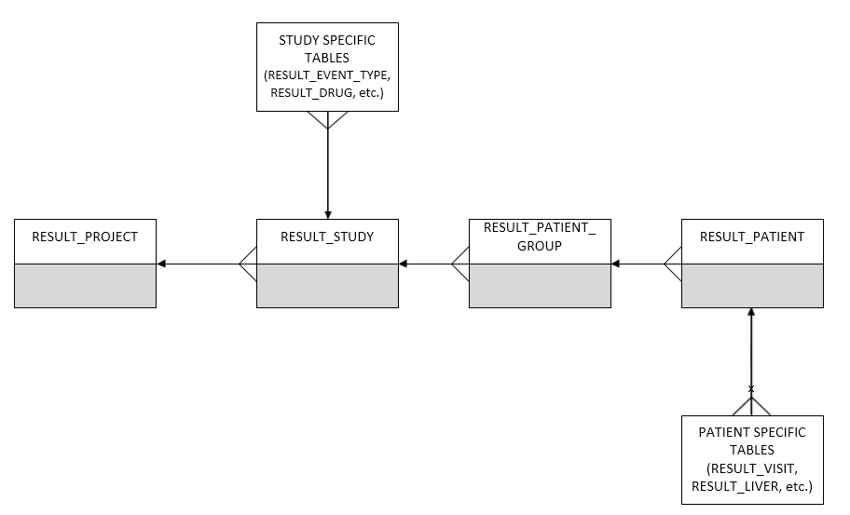

# How to Map Data to Data Model

## How to Start

Open your browser and go to the AdminUI web portal (<https://decmtreactprod.digitalecmt.com:447/admin>).

**Note**: Only a user with appropriate privileges can use AdminUI. (VA-Security application is used for providing users with roles and permissions. See Roles and Permissions section for details.)

If logging in was successful, a home page will open.

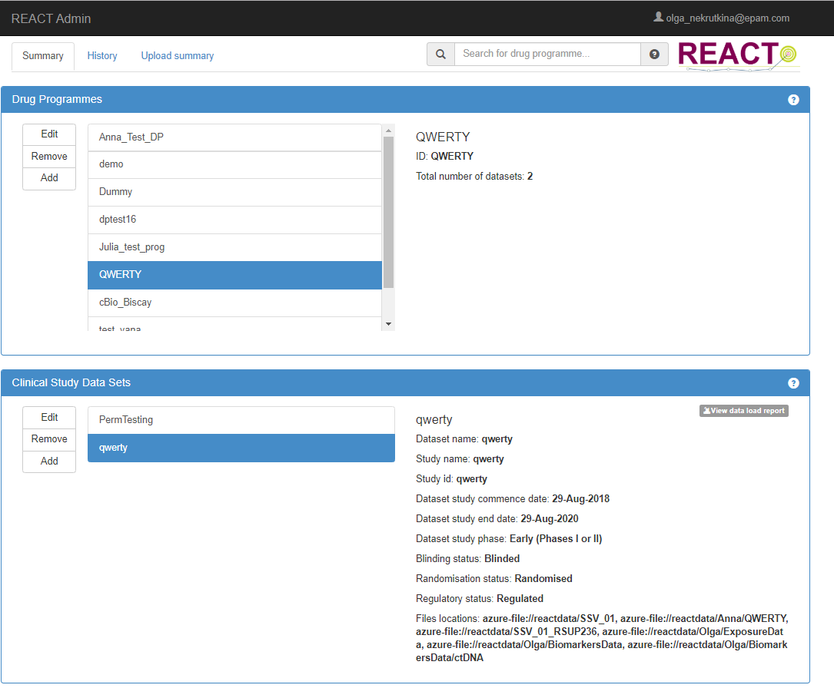

Home page contains three tabs:

* Summary
* History
* Upload summary

**History** tab provides a user with an Audit Trail – log of AdminUI settings changed by different users.

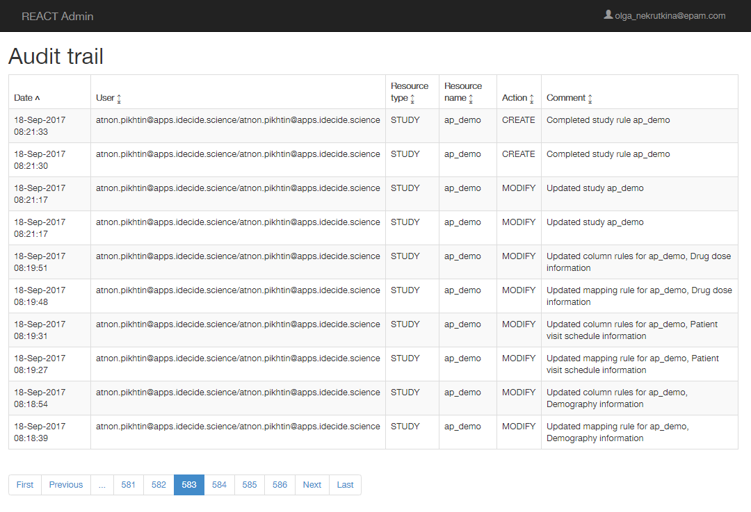

**Upload Summary** tab provides a user with log of uploaded files.

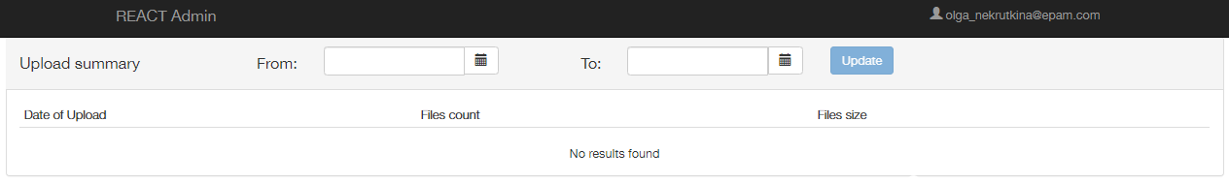

Choose **From** and **To** dates and click **Update**.

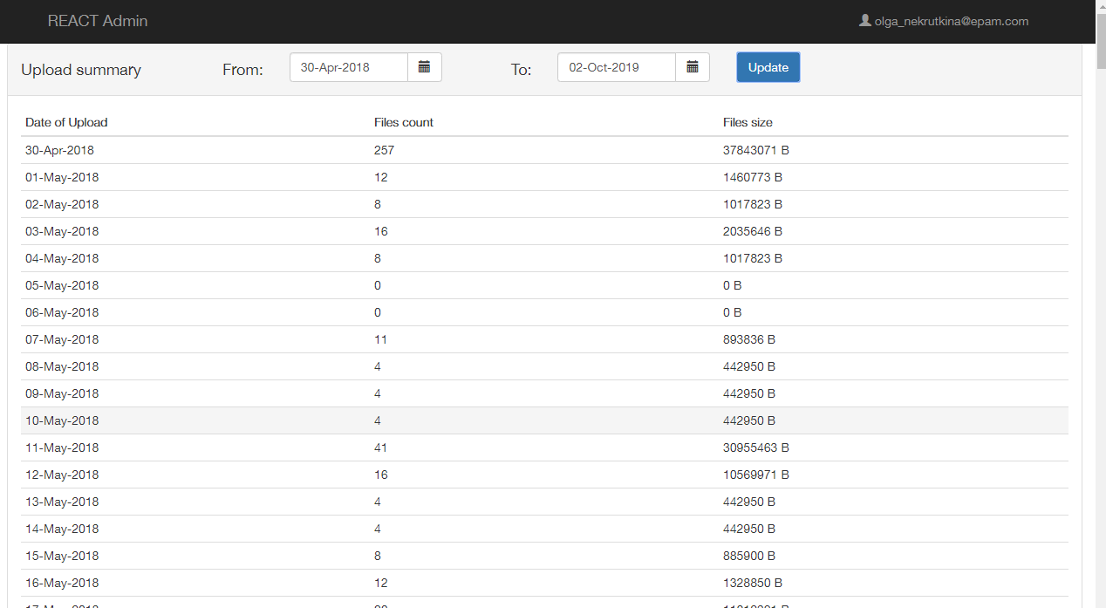

**Summary** tab contains two sections:

* Drug Programmes
* Clinical Study Datasets

**Drug programme** is a programme of work to investigate one or more drugs.

**Study** is a clinical study that is associated with a single drug programme.

**Dataset** is a set of data that is associated with a clinical study. Essentially such a dataset arrives in tabulated format.

In the **Drug Programmes** section a user can see a list of drug programmes that have been configured to use REACT. A user can use **Search** field to look for a particular drug programme by one of the following attributes:

* Programme name;
* Study name;
* Study code;
* Study primary location;
* Visualization name.

Here a user can select a programme, edit it, remove or add a new one.

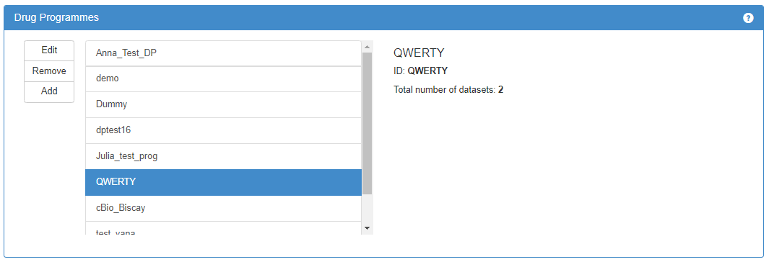

Available information on the selected drug programme is displayed to the right.

In the **Clinical Study Data Sets** section a user can see a list of Datasets that have been configured to use REACT for selected drug programme.

Here a user can select a dataset, edit it, remove, or add a new one.

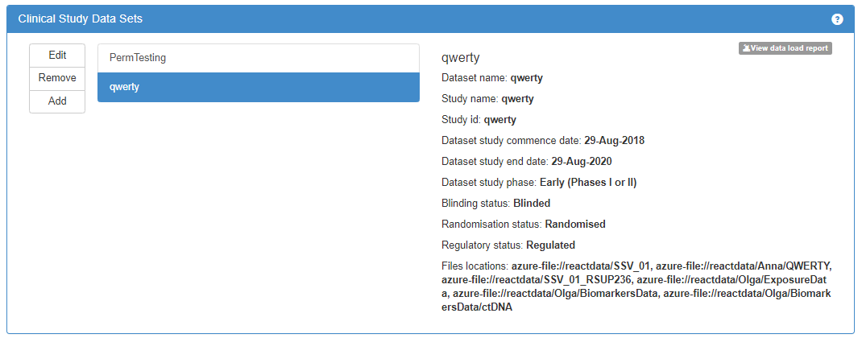

Available information on the selected dataset is displayed to the right.

## Add Drug Programme

1. Click **Add** in the **Drug Programmes** section to add a new drug programme.

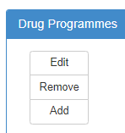

**Drug Programme Setup** page opens. Left menu provides a user with sequence of steps to configure a drug programme for using it in REACT. Click **Next** button or the successive menu item to follow the sequence (option stays unavailable until all required settings are set on the current step).

Click **Admin Home** (or **REACT Admin**) to return to the home page.

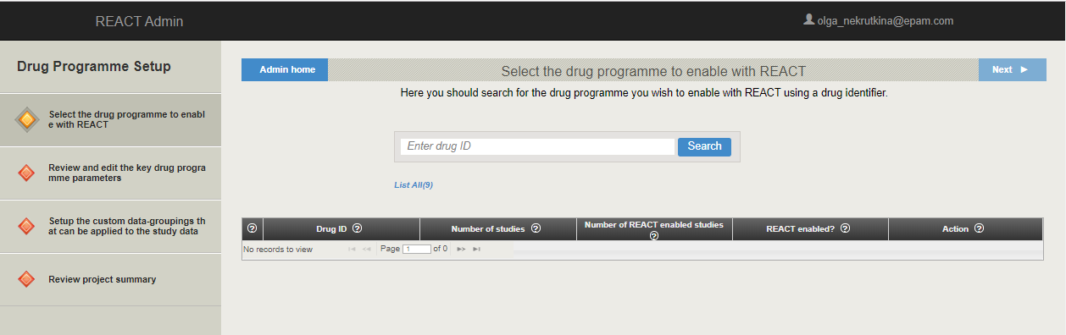

*  icon marks current step;
*  icon marks steps to pass;
*  icon marks passed steps.

2. Enter Drug ID for a new drug programme into the **Search** field and click **Search**. If the system finds the drug programme with similar id and displays it in the table below, then another drug id should be entered.

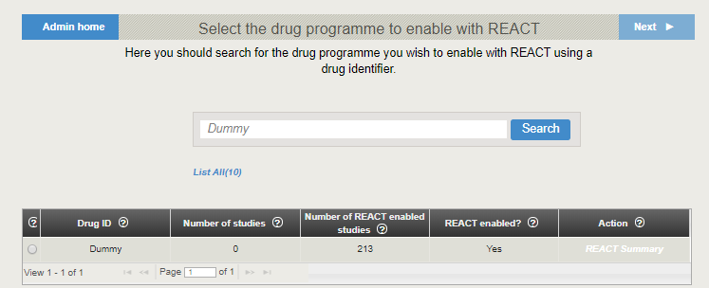

**Note**: Search results will include not only drug programmes, which id (or name) contains search string, but also drug programmes, which dataset id contains search string.

The image below provides an example of search result.

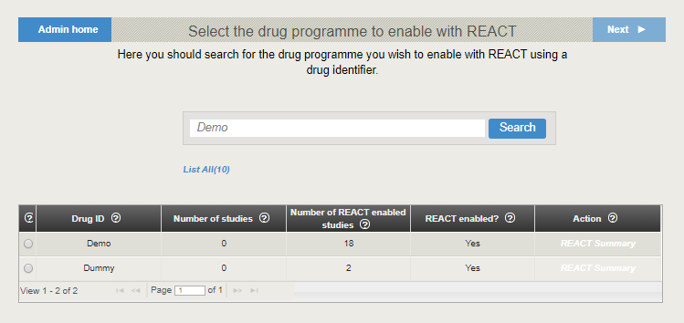

**Note:** It is also possible to view all drug programmes registered in the system by clicking **List All** link.

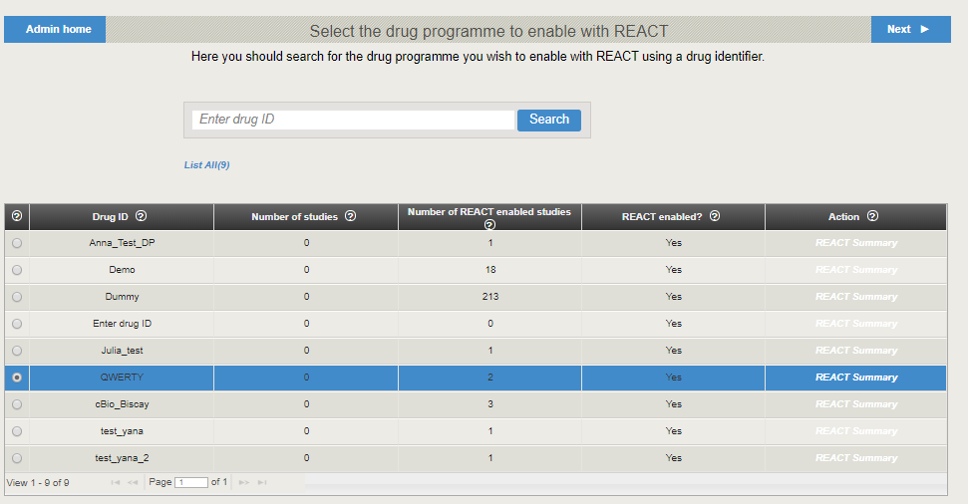

The following information is displayed in the table:

* Number of studies – total number of studies related to a selected drug programme.
* Number of REACT enabled studies – number of studies that were enabled for further configuration, i.e. data mapping.
* REACT summary – click this link to obtain information about the selected drug programme or edit its parameters.

3. If no drug programme was found, **Add New** button appears. Click the button.

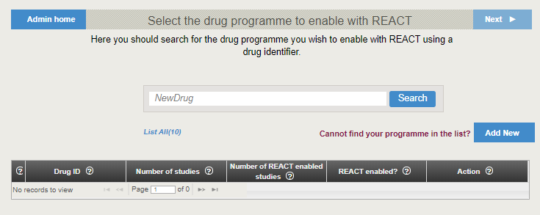

The next step allows a user to configure a new drug programme.

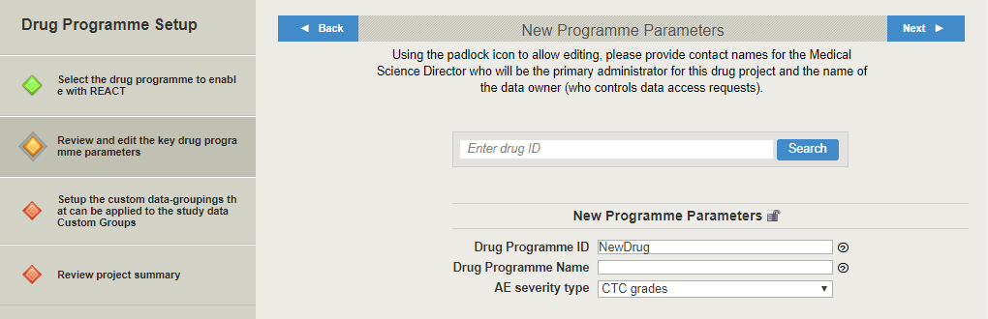

Here a user can set the following drug programme parameters:

* Drug programme id;
* Drug programme name – name that will be visible in REACT and VA-Security;
* AE severity type – rating scale for adverse events severity. It can be either CTC grades or AE Intensity.

4. Click **Next** (or click on the successive item of the left menu).

The next step allows a user to group Adverse Events sets or Lab Measurement sets, if required. Click **Add** to add a new Custom group.

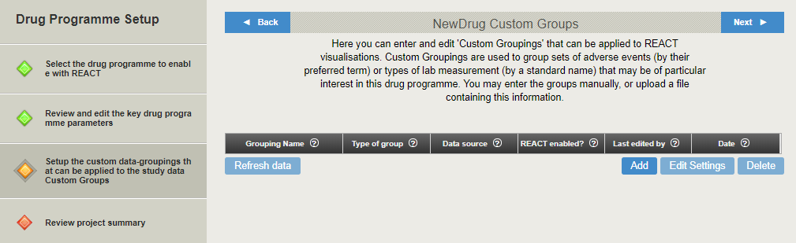

Pop-up window appears.

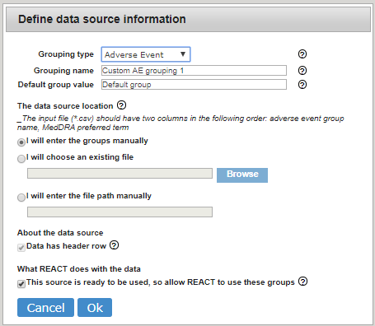

5. Set the following parameters:

* **Grouping type** can be either Adverse events or Lab Measurement;
* Grouping name;
* **Default group value** – values for the group name that will be assigned to any adverse event or lab measurement that are not explicitly assigned to a group in the data provided by the user;
* **Data source location** - groups can be entered manually or imported in a .csv file;
* **Data has header row** checkbox is not available for manual group entering. **Note**: Header row in the uploaded file will not be used in group;
* If **This source is ready to be used, so allow REACT to use these groups** checkbox stays unmarked, then created groups will be stored, but not available for using in visualizations.

**Note**: This checkbox value is displayed in **React enabled?** column of Groupings table.

**Note**: Source .csv file for Adverse events should have two columns, and for Lab measurements - three columns.

Set required parameters and click **Ok**.

Newly created group appears in the table. It can be deleted or edited by clicking on appropriate buttons.

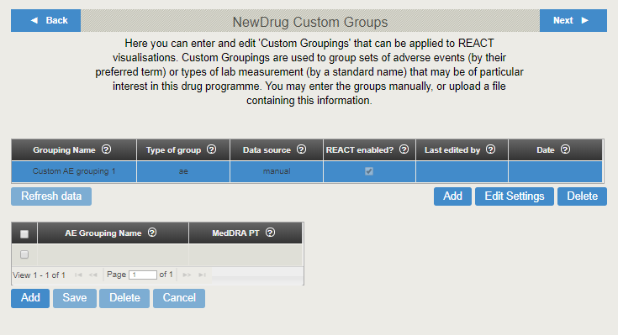

If manual entering of the group data was selected while creating the group, additional empty table appears below.

* Click in the empty table cell and type to enter a value.
* Click **Add** to add a row.
* Select required rows and click **Delete** to remove them.
* Click **Cancel** to discard changes.
* Click in the table cell to edit a value.
* Click **Save** to save changes.

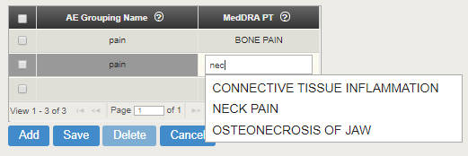

If a file was selected as a data source, a table with its contents also appears below the Grouping table.

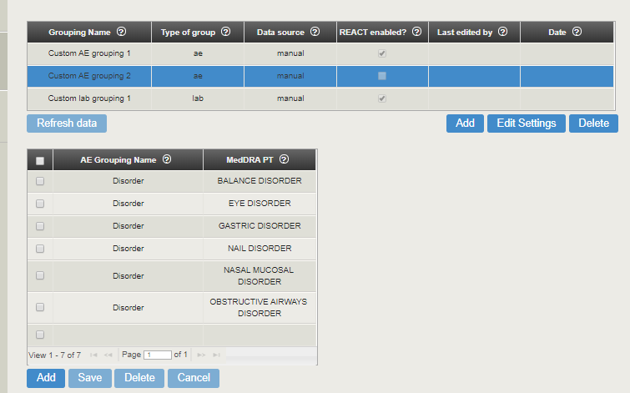

Its contents can also be edited or deleted.

Select grouping in the table and click **Edit Settings** to change the data source information.

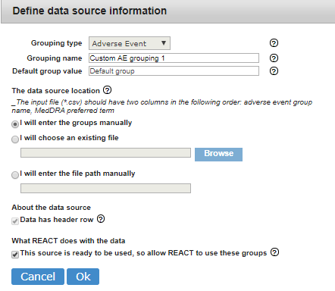

Here a user can change all information but the **Grouping type**.

6. Click **Next** (or click on the successive item of the left menu).

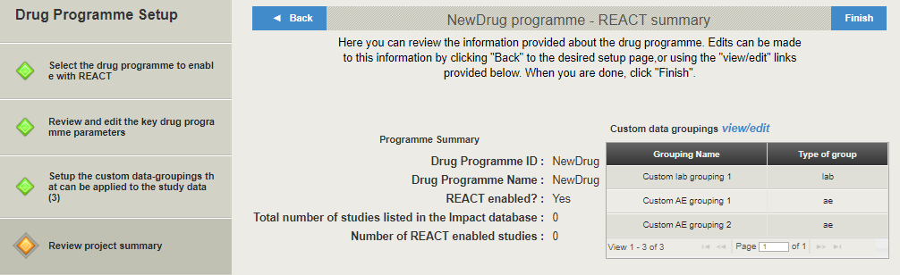

Here a user can view the summary of a new drug programme.

7. Go back to make changes or click **Finish**.

New drug programme is added to the Drug programmes list. Select it and add some datasets (see Add DataSet section).

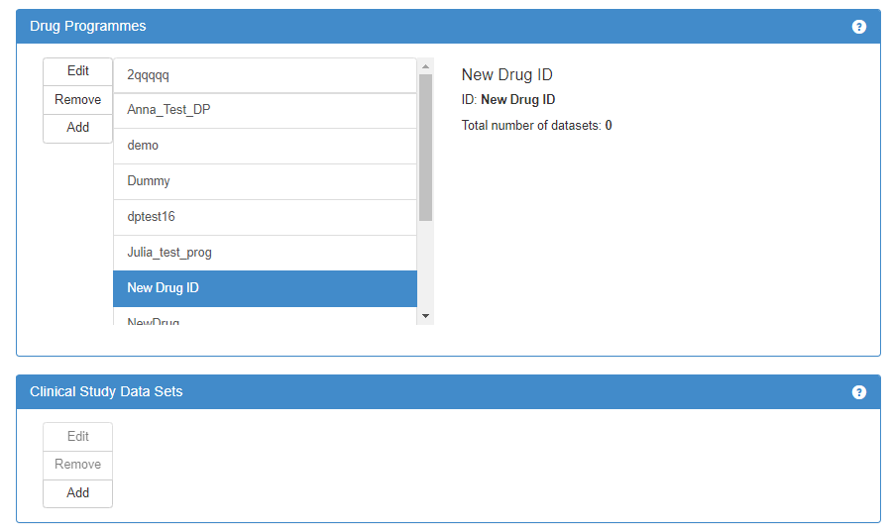

**Note**: If a user created a new drug programme and did not click **Finish** (but clicked **REACT Admin** to return to the home page), new drug programme will appear in the drug programmes list, but a user will be unable to add a dataset to it. In order to solve the issue, a user should select this drug programme in the list, click **Edit**, and click **Finish** in the **Drug Programme Setup.**

## Edit Drug Programme

1. Select required drug programme and click **Edit**.

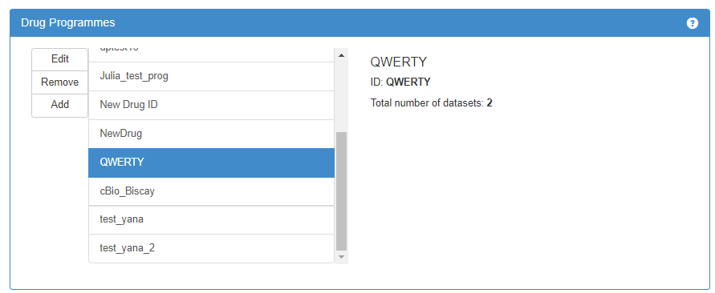

**Drug Programme Setup** opens, displaying programme summary.

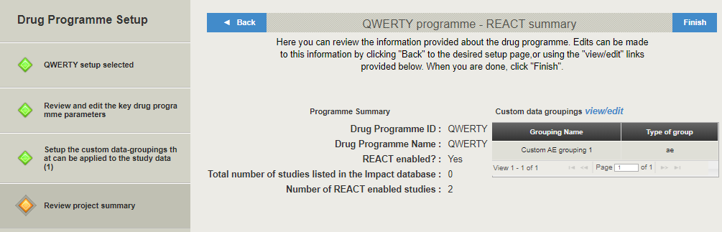

2. Click **Back** (or **view/edit** link, or **Setup the custom data groupings…** left menu item) in order to change custom data groupings for the programme.

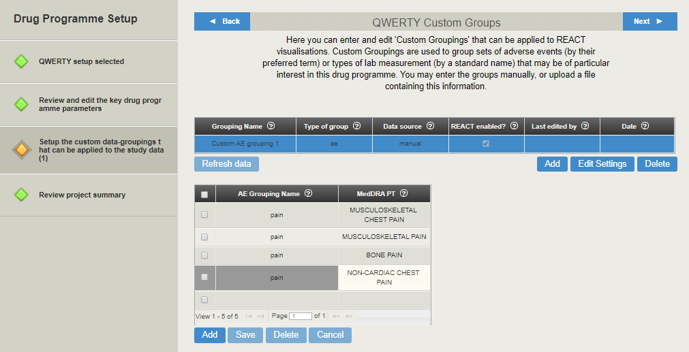

Here a user can add/delete/edit existing groupings. (See Add Drug Programme section for details.)

3. Click **Back** (or **Review and edit…** left menu item) to change key drug programme settings.

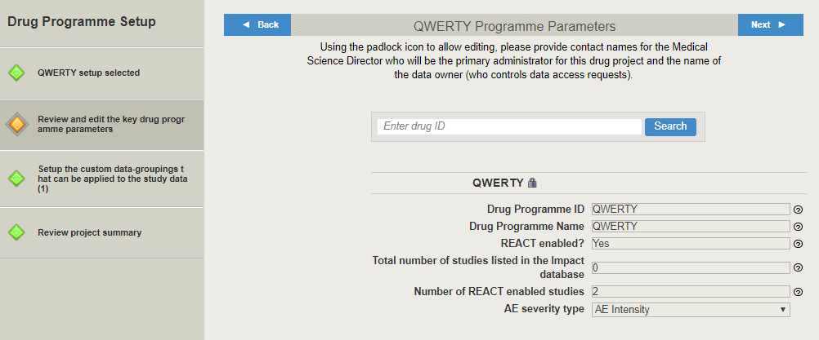

Click padlock icon  to edit available parameters of selected drug programme. Edit required parameters.

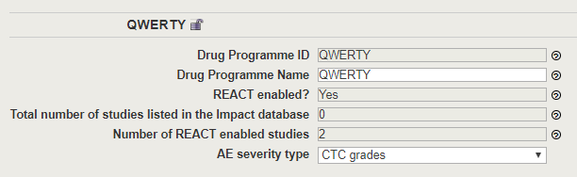

4. Click **Review project summary** left menu item. Click **Finish** in order to save changes and close the setup.



**Note**: A user also can click **Remove** in order to remove existing drug programme. This action will result in removing all related datasets too.

## Add Dataset

Select required drug programme in the **Drug Programmes** section. Datasets that have been configured to use REACT for selected programme are displayed in the **Clinical Study Data Sets** section.

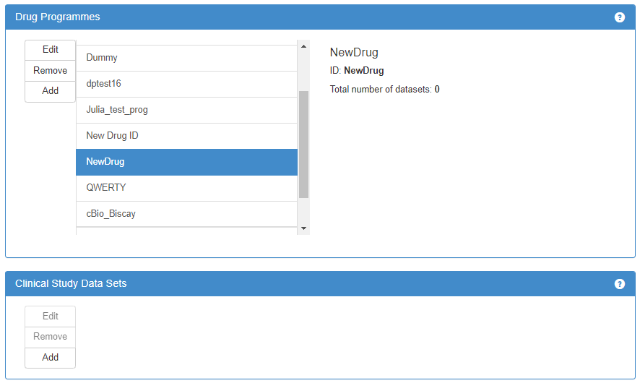

1. Click **Add** in the **Clinical Study Data Sets** section to add a new dataset.

**Clinical Study Setup** opens. Left menu provides a user with sequence of steps to configure a clinical study for using it in REACT. Click **Next** button or the successive menu item to follow the sequence (option stays unavailable until all required settings are set on the current step).

Click **Admin Home** (or **REACT Admin**) to return to the home page.

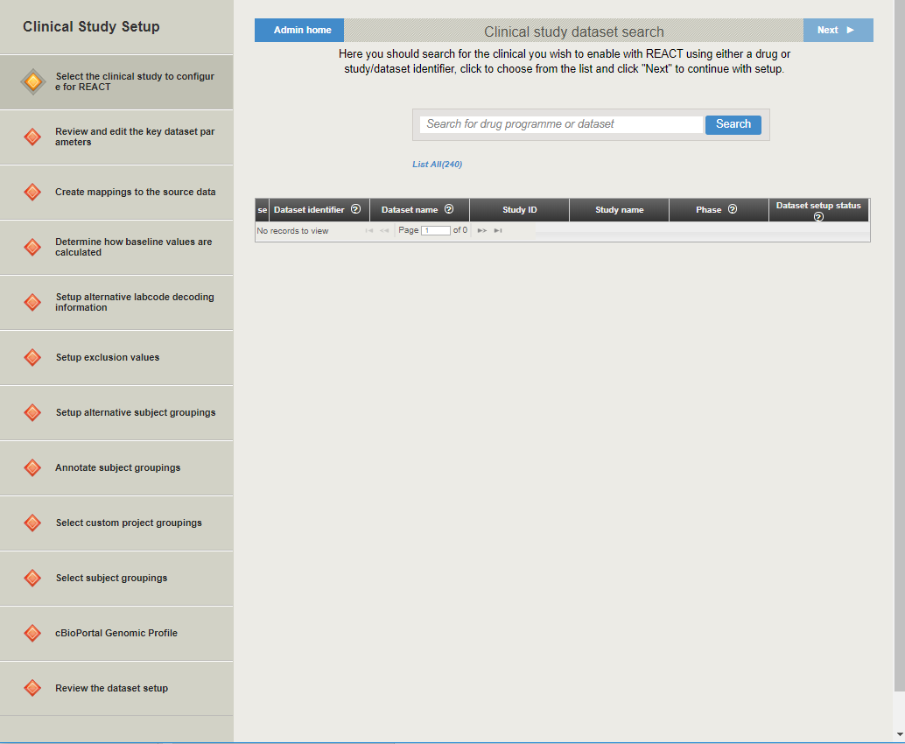

*  icon marks current step;
*  icon marks steps to pass;
*  icon marks passed steps.

### Add New Dataset

2. Enter Dataset ID for a new dataset into the **Search** field and click **Search**. If the system finds the dataset with similar id and displays it in the table below, then another dataset id should be entered.

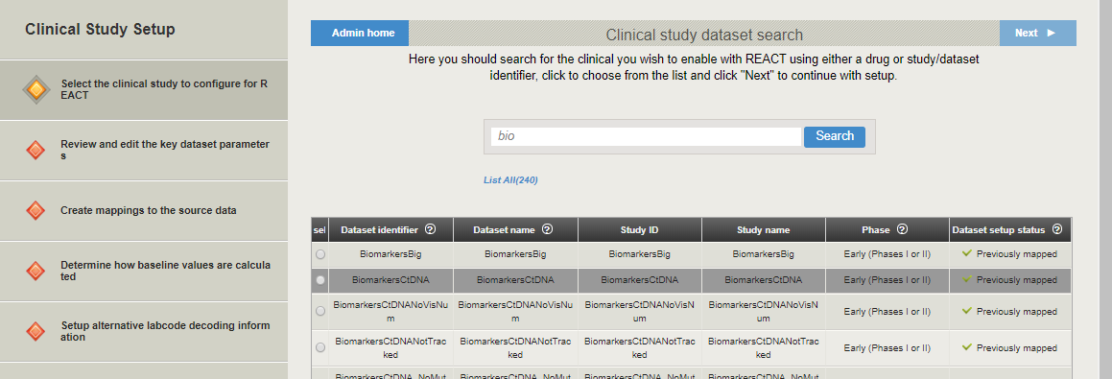

**Note**: Search results will include not only datasets, which id (or name) contains search string, but also drug programmes, which id (or name) contains search string.

**Note:** It is also possible to view all datasets registered in the system by clicking **List All** link.

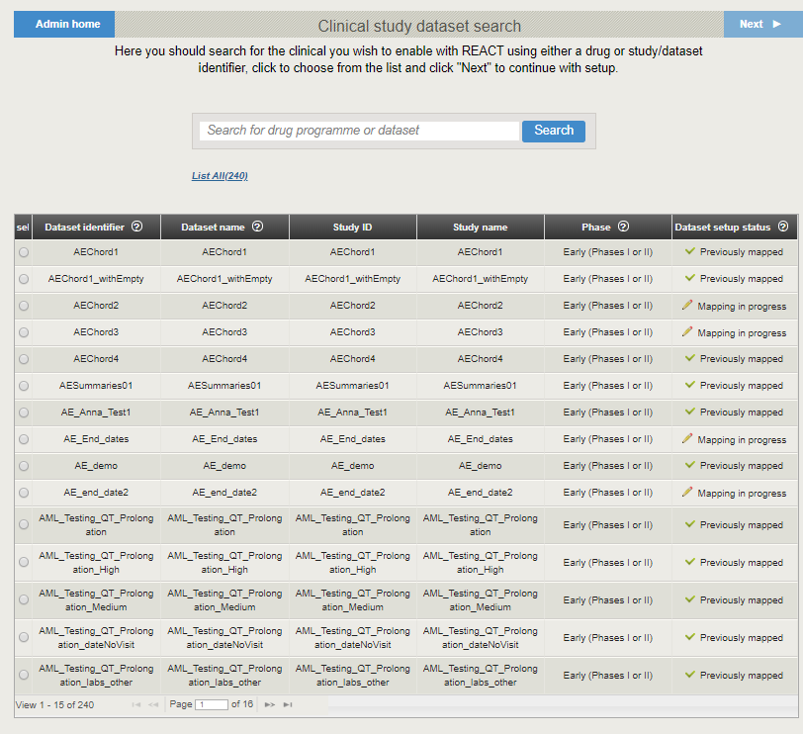

The following information is displayed in the table:

* Dataset ID;
* Dataset name;
* Study ID;
* Study name;
* **Phase** – clinical study phase;
* **Dataset setup status** – setup status of the study in REACT. The following values are available:
* **Not added to REACT** – study is not ready to be configured in REACT, because it was not allowed in the parent drug programme;

**Note**: Parent drug programme should be reconfigured to solve the issue.

* **Ready to map** – study is not configured;
* **Mapping in progress** – study configuration process is not completed yet;
* **Previously mapped** – mapping is sufficiently completed and enabled, so REACT can use study data in visualizations.

3. If no dataset was found, **Add New** button appears. Click the button.

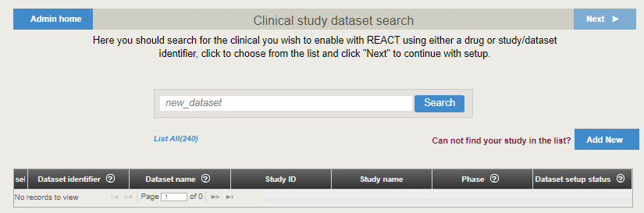

### Set New Dataset Parameters

The next step allows a user to configure a new dataset.

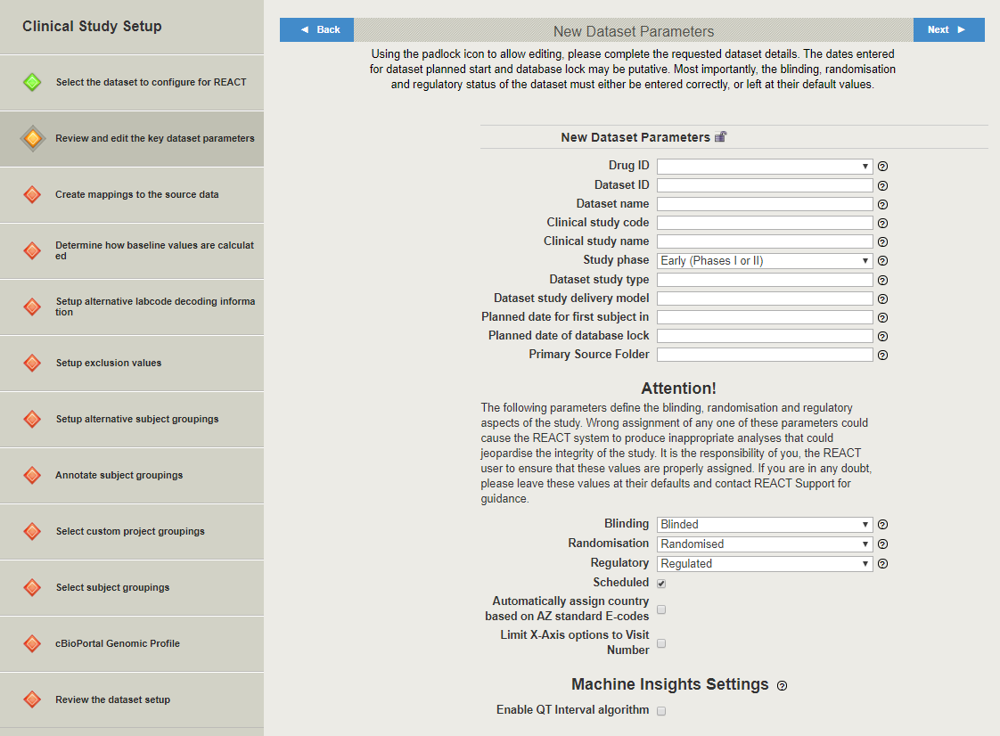

Here a user can set the following dataset parameters:

| Parameter | Mandatory | Description | Value range | Validation rules | Comment |
| --- | --- | --- | --- | --- | --- |
| Drug ID | Yes | Drug programme ID | Any drug programme  *,** |  |  |
| Dataset ID | Yes | Unique dataset ID used to organize data in REACT | Any | * Is not empty * No space characters |  |
| Dataset name | Yes | Name of dataset displayed in the VA-Hub, VA-Security | Any | * Is not empty * No space characters | This field is for user reference only. Does not affect data processing in REACT |
| Clinical study code | Yes | Unique ID for a study within REACT database | Any | * Is not empty * No space characters |  |
| Clinical study name | Yes | Name of study displayed in the VA-Hub, VA-Security | Any | Is not empty | This field is for user reference only. Does not affect data processing in REACT |
| Study phase | No | Clinical study phase | * Early * Late |  |  |
| Dataset study type | Yes | The type of study | Any | Is not empty | This field is for user reference only. Does not affect data processing in REACT |
| Dataset study delivery model | Yes | The organizational process through which the study is being made | Any | Is not empty | This field is for user reference only. Does not affect data processing in REACT |
| Planned date for first subject in | Yes | For ongoing studies it is an actual date of the first subject dosing; for prospective studies – an estimation for appropriate date | Calendar item | Is not empty | This value is used for data updates timing estimations. Can be modified later |
| Planned date of database lock | Yes | An estimation for the date when the primary database lock will occur | Calendar item | * is not empty * is not in the past * is not before planned date for first subject in | This value is used for REACT shut down timing estimations. Can be modified later |
| Primary source folder | No | Location of the source files (usually – CAVE location for appropriate SAS files) | Any, with additional confirmation if is not a valid location | Is valid location | This location is used for automatic mapping (on the next step) |

**\*** If a user created a new drug programme and did not click **Finish** (but clicked **REACT Admin** to return to the home page), new drug programme will appear in the drug programmes list on the home page, but a user will not find this drug programme in the Drug ID field list at **Clinical Study Setup**. In order to solve the issue, a user should select this drug programme in the list, click **Edit**, and click **Finish** in the **Drug Programme Setup.**

**\*\*** A user may have no permissions to add a dataset to the particular drug programme. See Roles and Permissions section for details.

**Note:** A user can either enter parameters (name and id) of existing clinical study, or parameters of a new study, that will be created.

The next set of parameters strongly affects accuracy and integrity of the study. **A USER SHOULD LEAVE THERE DEFAULT VALUES IN CASE OF ANY DOUBT**.

* **Blinding** – defines whether a study has blinding aspect, or not;
* **Randomization** - defines whether study subjects are randomized between arms, or not;
* **Regulatory** - defines whether a study will deliver/support licensing submission, or not.

Additionally, some checkboxes are provided below.

* **Scheduled** – If this checkbox is marked, then ETL service will run every day, look for source data update, and update the data in the database, if required.
* **Automatically assign country based on AZ standard E-codes** - If this checkbox is marked, then E-codes can be used instead of countries, when Countries mapping is used.
* **Limit X-axis options to visit number** – Date/number of visit may be measured on the X-axis for some plots. If this checkbox is marked, then visit numbers only can be measured on the X-axis for such plots.
* **Enable QT Interval algorithm** – marking this checkbox enables using Azure Machine Learning Studio to create Machine Insights QT interval plot. In this case, Additional visualization module View Machine Insights appears in VA-Hub, providing users with QT Prolongation plot.

4. Set the parameters and click **Next** (or click on the successive item of the left menu).

### Create Data Mappings

The next step allows a user to map source clinical data into the system. Only mapped data will be available in REACT visualisations.

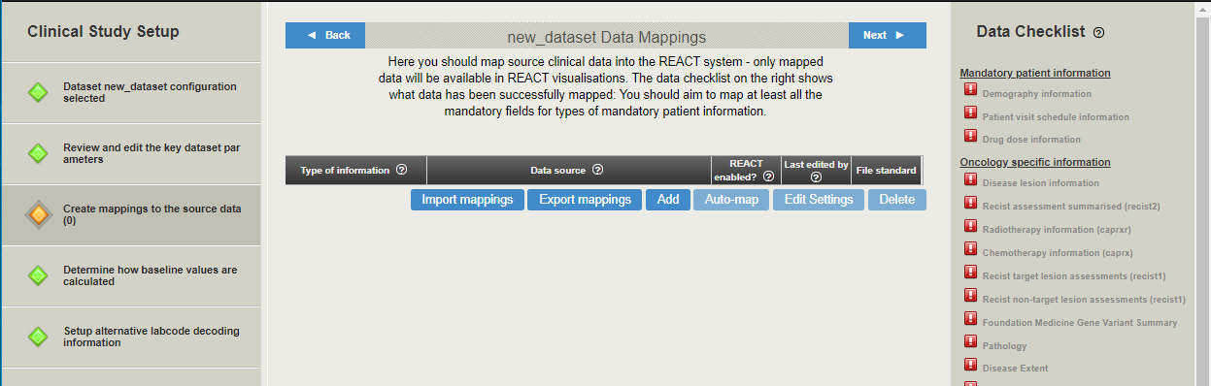

Section to the right provides a user with the Data Checklist. Here a summary of the mapping process is displayed.

*  icon marks information types that are not completely mapped;
*  icon marks information types that are being mapped;
*  icon marks information types that are completely mapped to a minimum acceptable level.

All data types divided by groups are listed at the Data Checklist section.

The following data types are mandatory:

* Demography information;
* Patient visit schedule information;
* Drug dose information.

These data types are grouped under **Mandatory patient information** name.

Each data type consists of set of fields, some of them are mandatory (see also Mappings Details section for details).

**Note**: At least mandatory fields of mandatory data types should be mapped.

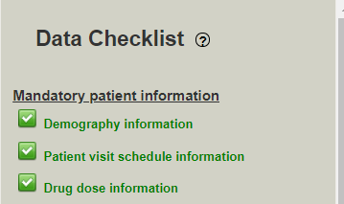

5. Click **Add** to add one mapping. Pop-up window appears.

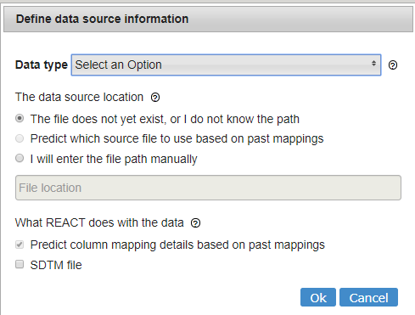

Here a user can set the following parameters:

* **Data type** – select required data type from the drop-down list;
* **Data source location** - data file in a .csv or SAS format can be imported immediately (3rd options) or later (1st option). Additionally, if **Primary source folder** was set on the previous step, 2nd option becomes available. If 2nd option radio-button is selected, system will look for the source file with appropriate name in the primary source folder;

**Note**: Depending on REACT version, a file could be stored in Azure file storage (azure-file://reactdata/..) or on local storage (/usr/local/patientdata/).

* **Predict column mapping details based on past mappings** – this checkbox becomes available only if either **Predict which source file…** or **I will enter the file path manually** radio-button is selected. If this checkbox is marked, system will use past mappings for the current drug programme (selected on the previous step) for prediction.
* **SDTM file** – this option is currently disabled.

Click **OK**.

Added mapping is displayed as a row in the Mappings table, and another table providing mapping details appears below.

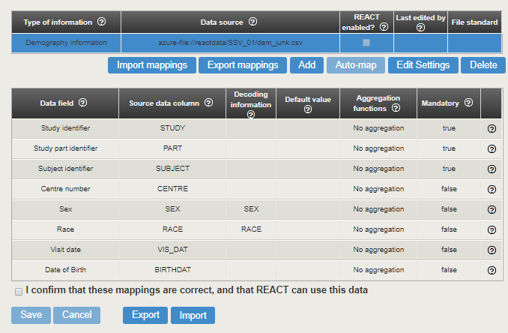

This table contain the following columns:

* **Data field** – fields that align with current data type;
* **Source data column** – name of the source data file column that maps to selected data field;

**Note**: Multiple columns can be mapped to one data field (separated by commas).

* **Decoding information** – value in this column should be equivalent to the ‘code group name’ value in the value decoding file. Mapping for the value decoding file should be created first (SAS value decoding information);
* **Default value** – this value will be assigned to the REACT field, if the source data is blank or there is no equivalent column in the source data;
* **Aggregation functions** – these functions allow the REACT to work with complicated data mapping requirements. Is not required for most part of the mapped data. See Aggregation Functions: Details and Examples section for additional details and examples;
* **Mandatory** – defines whether data field is mandatory or not. Mandatory field cannot be empty.

**Note**: Auto-complete function suggests a user values for strings in the **Source data** **column**, taken from a list of unique values of the column headers in the mapped file. It also checks strings in the **Source data** **column** against unique values in the list of the column headers in the mapped file.

**Note**: Auto-complete function suggests a user values for strings in the **Decoding information** column, taken from a list of unique values in the SAS decoding file. It also checks strings in the **Decoding Information** column against unique code values in the relevant column in the specified SAS value decoding information file.

A user can perform the following actions here:

* Edit table cells manually. Source data column values can be selected from drop-down list with available source data file column names.

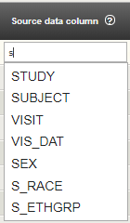

* Export current mapping as .csv file by clicking **Export**.
* Import mapping as .csv file by clicking **Import**.
* Mark confirmation checkbox in order to enable mapping for using in REACT.
* Save or cancel changes by clicking appropriate buttons.

Select mapping in the table and click **Edit Settings** to change the data source information. Pop-up window appears.

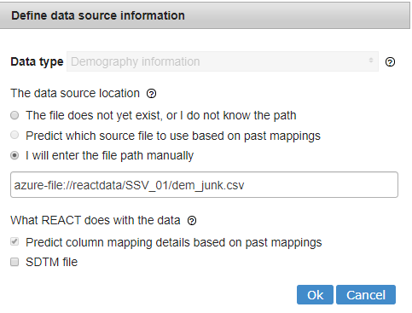

Here a user can change all information but the **Data type**.

Additionally a user can click **Import mappings** to import all required mappings together in one .csv file.

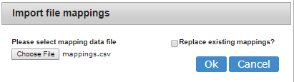

Choose the file and click **OK**.

It is also possible to export all required mappings together in one .csv file by clicking **Export mappings**.

**Note**: **Auto-map** function is currently disabled.

**Note:** If several mappings are available for the same data type, these mappings will be merged.

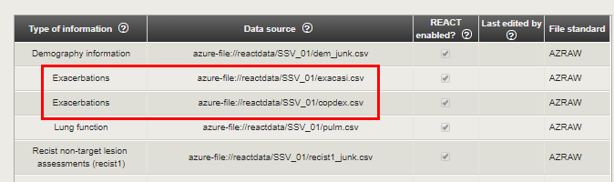

**Data source** column contain clickable links to source files used for mapping.

6. Ensure that all necessary mappings are created (at least three mandatory ones) and click **Next** (or click on the successive item of the left menu).

### Specify Baseline Calculations

The next step allows a user to specify the way baseline values are calculated in REACT, if this way should differ from the common one.

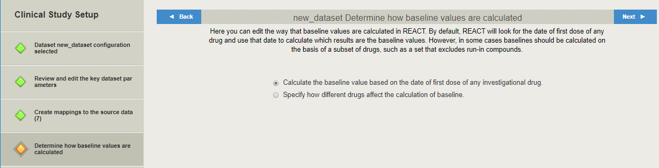

Select **Specify how different drugs affect the calculation of baseline** radio-button, if baseline should be calculated based on the particular drug.

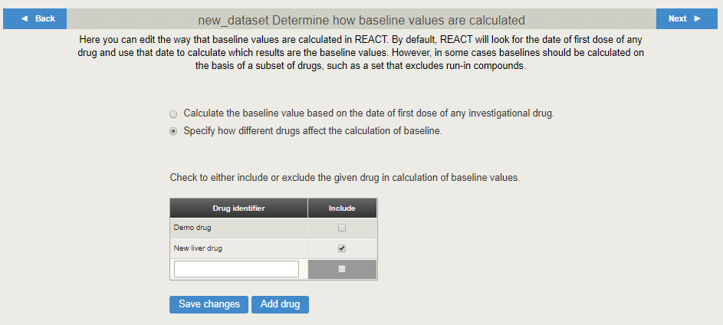

A table appears below. It contains drug ids taken from the **Drug dose information** mapping.

Here a user can mark/unmark some drugs to include/exclude them to the baseline calculation. A user also can add the ID of required drugs.

Click **Add drug** to add one more row to the table. Click **Save changes** when all required drugs are added to the table and all necessary checkboxes are marked/unmarked.

7. Click **Next** (or click on the successive item of the left menu).

### Map Labcode Decoding Information

The next step allows a user to map labcode decoding information other than AZ RAW.

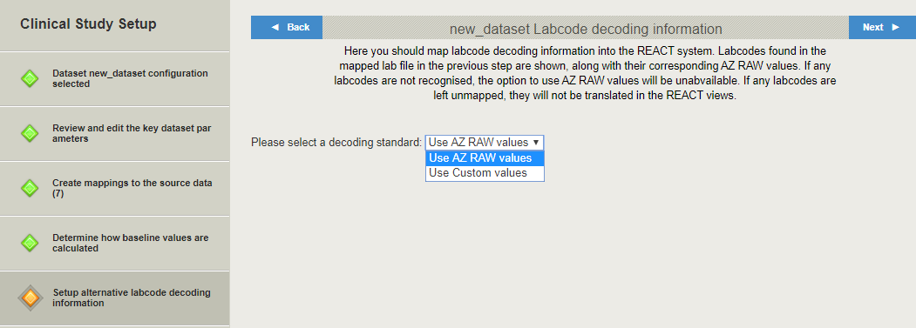

If **Use Custom values** standard is selected, decoding table appears below.

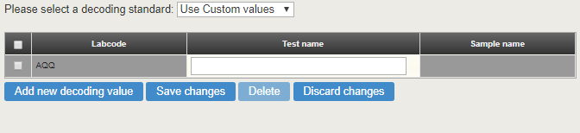

Here a user can perform the following actions:

* Add a row by clicking **Add new decoding value**. **Labcode** value should be entered manually, whereas **Test** and **Sample** names can be selected from the list with appropriate AZ RAW values or entered manually.
* Delete a row;
* Save or discard changes.

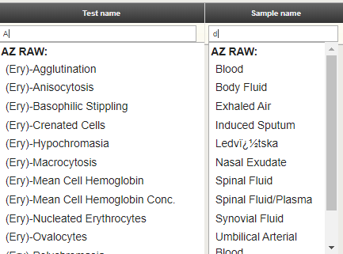

When decoding labcodes, the order of preferrence for decoding information is as follows:

1. Custom values
2. If a labcode is not found in the custom list, AZ RAW values should be checked.
3. If a labcode cannot be found in either the custom list or AZ RAW, the labcode should be displayed as the input labcode in the database view.

**Note**: **Labcode** values should be consistent with the labcodes from Laboratory results mapping.

8. Click **Next** (or click on the successive item of the left menu).

### Set Exclusions

The next step allows a user to exclude some values from the visualization, if required.

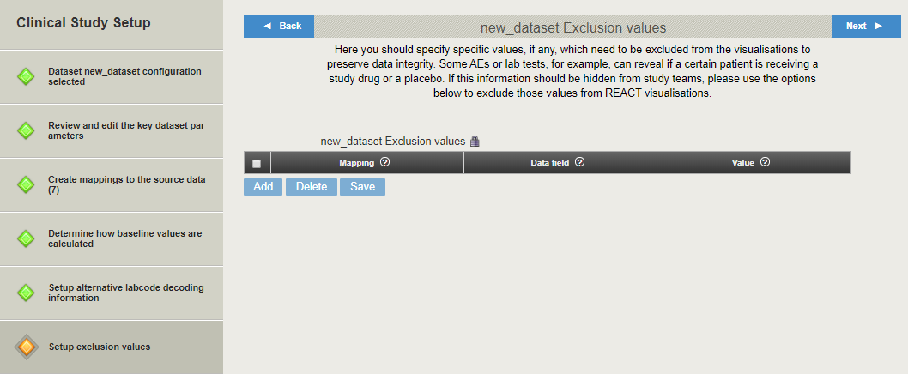

Click padlock icon  to unlock the **Exclusion values** table.

Here a user can perform the following actions:

* Add a row by clicking **Add**. Select a mapping from the drop-down list, then select a field of this mapping from the drop-down list, and enter a value to be excluded;
* Delete a row;
* Save changes.

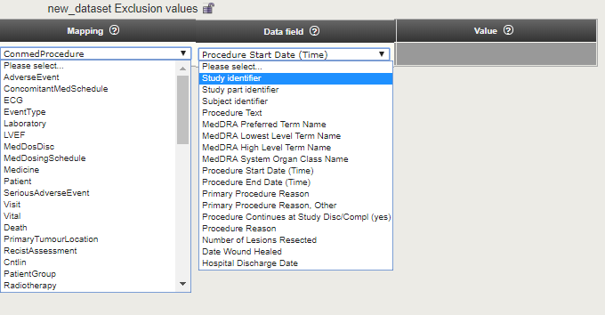

9. Click **Next** (or click on the successive item of the left menu).

### Create Alternative Subject Groupings

The next step allows a user to group sets of subjects that may be of special interest in current dataset.

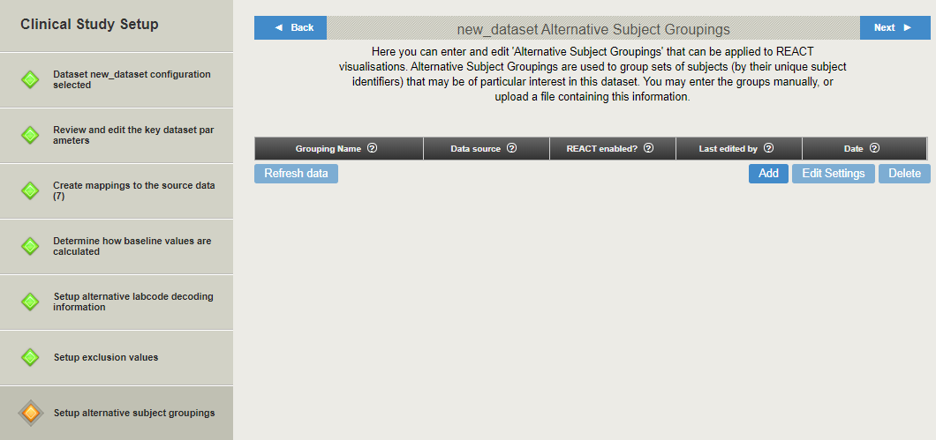

Click **Add** to add a new group. Pop-up window appears.

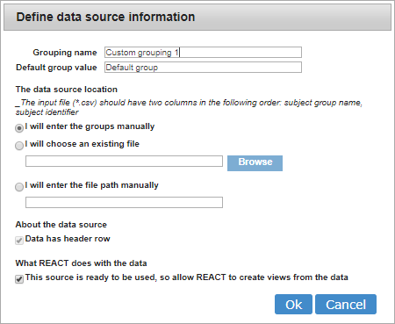

Set the following parameters:

* **Grouping name**;
* **Default group value** – values for the group name that will be assigned to any subject that is not explicitly assigned to a group in the data provided by the user;
* **Data source location** - groups can be entered manually or imported in a .csv file;
* **Data has header row** checkbox is not available for manual group entering. **Note**: Header row in the uploaded file will not be used in group;
* If **This source is ready to be used, so allow REACT to create views from the data** checkbox stays unmarked, then created groups will be stored, but not available for using in visualizations.

**Note**: Source .csv file should have the following two columns: subject group name, subject id.

Set required parameters and click **Ok**.

Newly created group appears in the table. It can be deleted or edited by clicking on appropriate buttons.

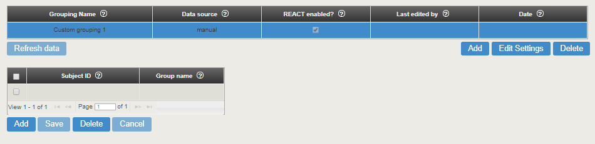

If manual entering of the group data was selected while creating the group, additional empty table appears below.



* Click in the empty table cell and type to enter a value.
* Click **Add** to add a row.
* Select required rows and click **Delete** to remove them.
* Click **Cancel** to discard changes.
* Click in the table cell to edit a value.
* Click **Save** to save changes.

If a file was selected as a data source, a table with its contents also appears below the Grouping table.

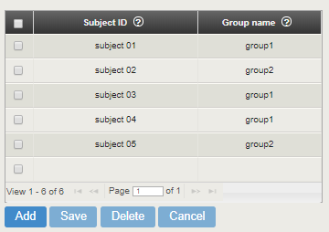

**Note**: For each grouping, each subject in the grouping can be assigned to only one group.

Table contents can also be edited or deleted.

Select grouping in the table and click **Edit Settings** to change the data source information.

10. Click **Next** (or click on the successive item of the left menu).

### Annotate Subject Grouping

The next step allows a user to perform the following actions with sets of subjects that were recently grouped:

* Assign to a specific type of cohort;
* Annotate with additional information.

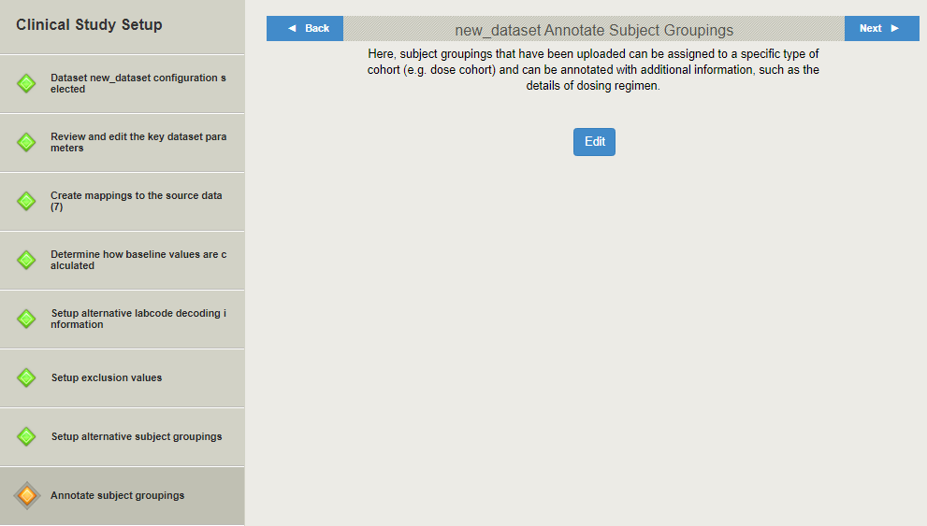

Click **Edit**. Another browser tab opens.

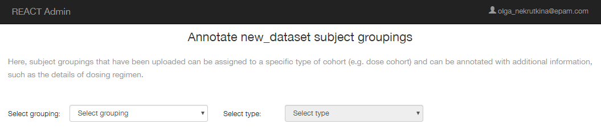

Select grouping from the list. Groupings that were recently created are available.

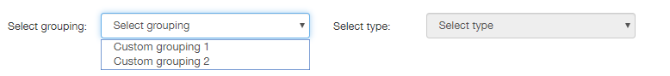

**Note**: Additional grouping may appear in the drop-down list, if it was specified in the **Patient group information** (**long and thin** or **short and wide**) mapping, added to the dataset.

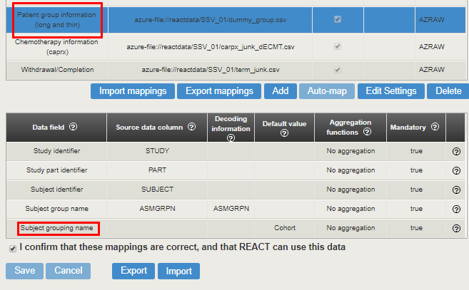

After the grouping is selected, type selection becomes available. The following cohort types are provided:

* None;
* Dose;
* Biomarker.

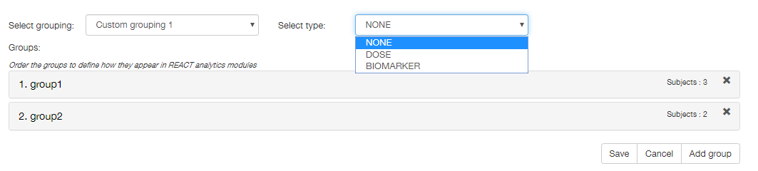

Contents of the selected grouping (groups and number of subjects included) is provided below.

Here a user can perform the following actions:

* Reorder groups by dragging them;
* Add more groups (but not subjects) by clicking **Add group** button;

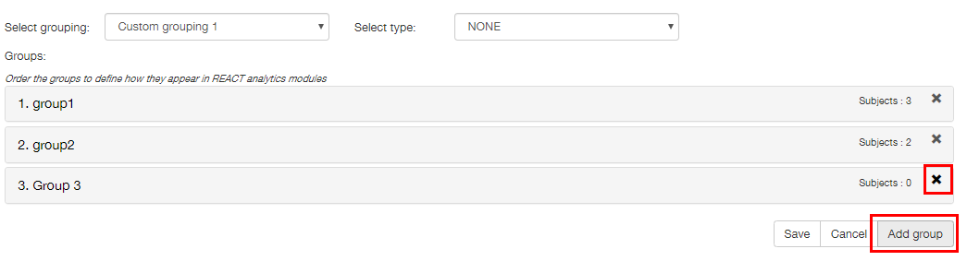

**Note**: A newly created group can be removed by clicking  button. Groups that were created on the previous step cannot be removed in this way.

* Annotate each group by clicking group name;
* Save or cancel changes.

If **None** or **Biomarker** cohort type was selected, only preferred name can be included into annotation block.

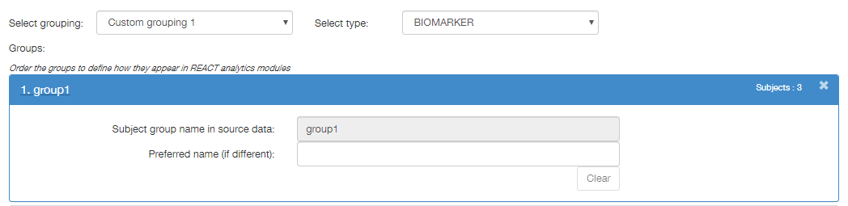

If **Dose** cohort type was selected, **Dose** tab appears in the annotation block, allowing a user to add some drugs and appropriate dosing details (so later a Va-Hub user will be able to compare planned dosing schedule vs actual).

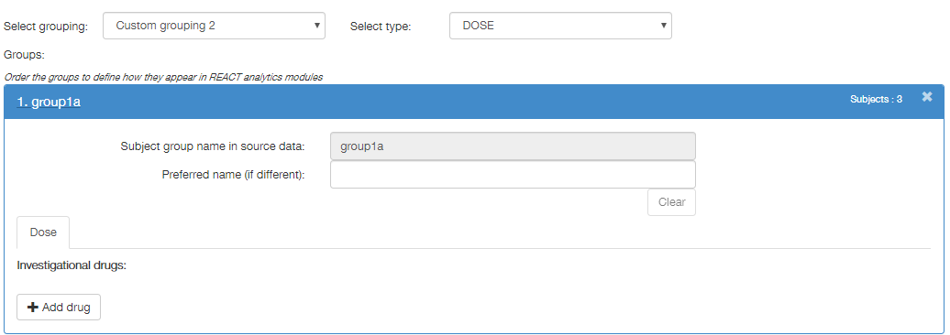

Click **Add drug**. Drug name field and **Dosing** **details** section appears.

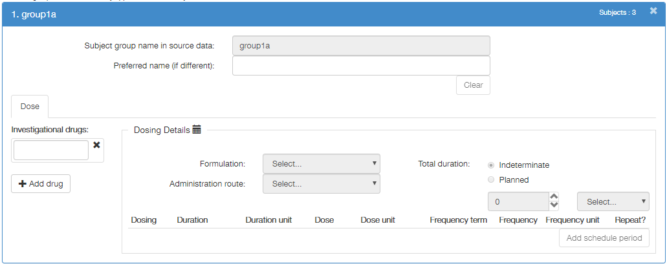

Enter drug name. **Formulation** and **Administration route** fields becomes active. Select appropriate formulation and route from the drop-down lists.

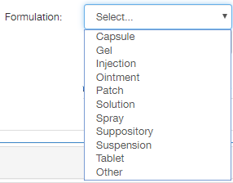 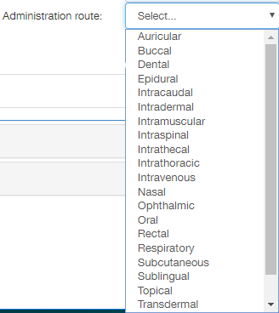

Select **Total duration** – **Indeterminate** or **Planned**. If **Planned** radio-button is selected, then two fields below becomes available, allowing a user to specify duration.

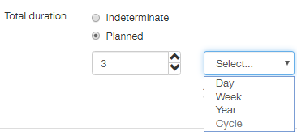

Click **Add schedule period** to specify the dosing regimen. A user can add some periods with different schedules, if required.

The following parameters can be specified:

* **Dosing** – describes whether patient gets treatment or not. Possible values: **On** or **Off**. If **Off** value is selected, only **Duration** and **Duration unit** parameters are available.
* **Duration** – describes total treatment duration. Possible values: **Continuous** or numeric values. If **Continuous** value is selected, **Duration unit** parameter becomes unavailable.
* **Duration unit** – follows **Duration** parameter. Possible values are provided on the picture below.

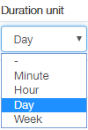

* **Dose** – describes drug dosing. Possible values are numeric.
* **Dose** **unit** – follows **Dose** parameter. Possible values are provided on the picture below.

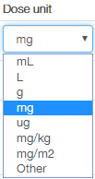

* **Frequency term** – describes frequency of drug taking. Possible values are provided on the picture below.
* These values are aligned with **Frequency** and **Frequency** **unit** values, and selected value may change automatically when **Frequency** or **Frequency** **unit** value is changed. Conversely, selected **Frequency** or **Frequency** **unit** value may change automatically when **Frequency** **term** value is changed.

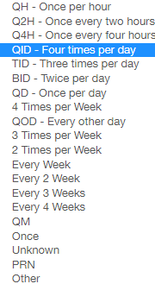

* **Frequency** – follows **Frequency term** parameter. Possible values: ‘-‘ or numeric.
* These values are aligned with **Frequency term** values, and selected value may change automatically when **Frequency term** value is changed. Conversely, selected **Frequency term** value may change automatically when **Frequency** value is changed.
* **Frequency unit** - follows **Frequency term** parameter. Possible values are provided on the picture below.
* These values are aligned with **Frequency term** values, and selected value may change automatically when **Frequency term** value is changed. Conversely, selected **Frequency term** value may change automatically when **Frequency** **unit** value is changed.

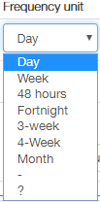

**Example**: If ‘BID-Twice per day’ **Frequency term** value is chosen, then **Frequency** value automatically changes to ‘2’, and **Frequency unit** value – to ‘Day’.



Next, if a user changes **Frequency unit** value to ‘Week’, then **Frequency term** value automatically changes to ‘2 Times per Week’.

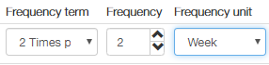

Next, if a user changes **Frequency** value to ‘5’, then **Frequency term** value automatically changes to ‘Other’.



Next, if a user changes **Frequency term** value to ‘Unknown’ (or ‘PRN’), then both **Frequency** and **Frequency unit** values automatically change to ‘-’.



* Repeat - this value indicates whether the record will be included (checkbox is marked) or will not be included (checkbox is clear) in a repeating cycle of dosing.

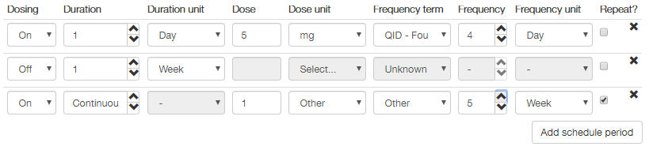

Finally, a user can click **Save** when finished annotating process, in order to save changes.

11. Click **Next** (or click on the successive item of the left menu).

### Select Custom Project Grouping

The next step allows a user to select custom adverse events and/or lab groupings to use them in visualizations.

**Note**: Custom adverse events and lab groupings should be previously created for appropriate drug programme. See Add Drug Programme section for details.

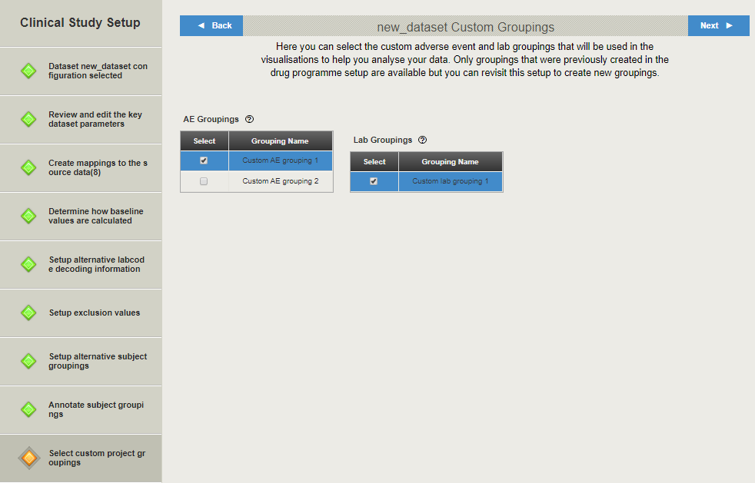

Tables with available adverse events and lab groupings are provided on the page. Mark checkbox besides required grouping in order to select it.

12. Click **Next** (or click on the successive item of the left menu).

### Select Subject Groupings

The next step allows a user to select subject groupings that will be used in the visualizations.

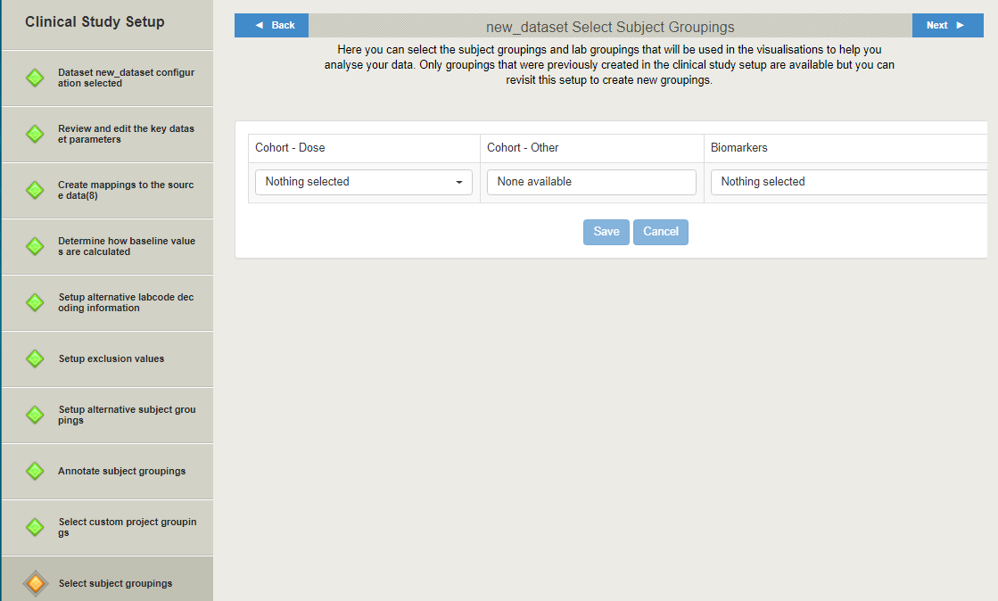

On the step described in Annotate Subject Grouping section, different cohort types were assigned to subject groupings – Other, Dose, and Biomarkers. On this page, a user can select one subject grouping per each type to use them in the visualizations.

**Note**: ‘None available’ means that no subject groupings of this type were found.

**Note**: **Other** there corresponds to **None** in Annotate Subject Grouping section.

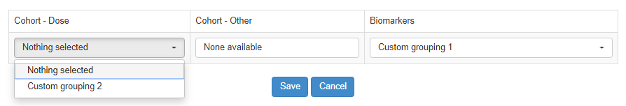

Select required groupings and click **Save**.

12. Click **Next** (or click on the successive item of the left menu).

### Select Genomic Profiles

The next step allows a user to select genomic profiles to be used for the Genomic Profile visualization. This option can be used only if genomic data is included into the current dataset, i.e. if Genomic Profile Biomarker Results mapping was created.

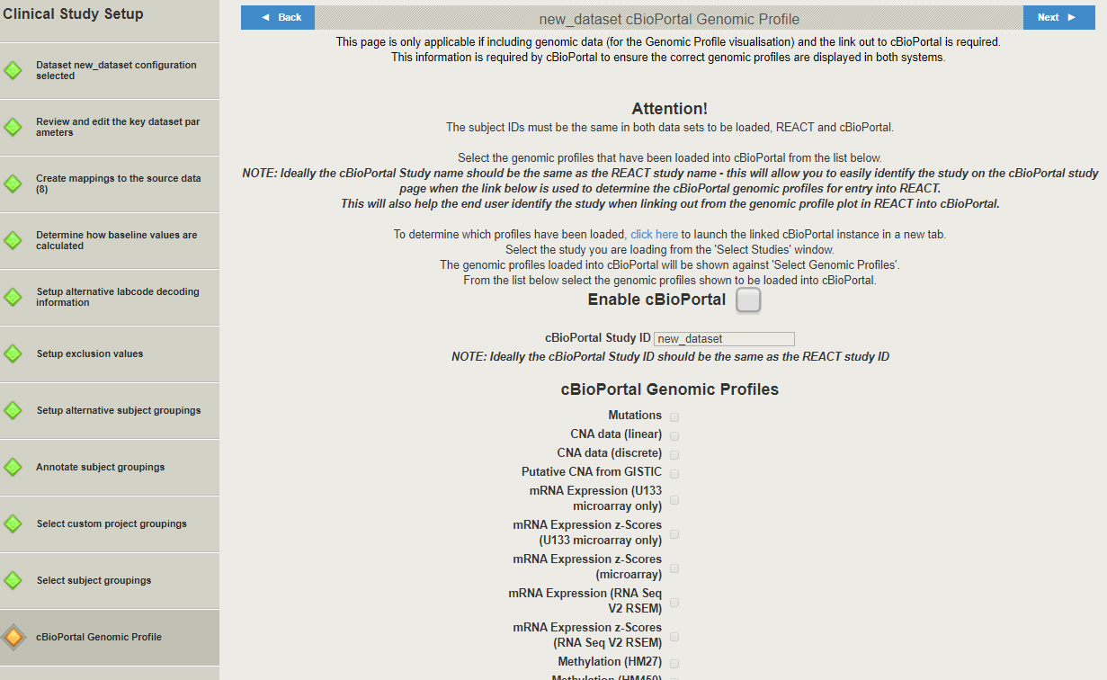

Genomic Profile visualization in VA-Hub provides a user with possibility to open cBioPortal application, work there with appropriate genomic data, and return to VA-Hub. Thus, the following arrangements should be made:

* A study with the same genomic data should be in cBioPortal;
* Some genomic profiles (of provided in the genomic data) should be specified.

A user should comply the following restrictions:

* The subject IDs MUST be the same in both data sets loaded into REACT and cBioPortal.
* Ideally the cBioPortal Study name should be the same as the REACT study name.
* Ideally the cBioPortal Study ID should be the same as the REACT study ID.

Mark **Enable cBioPortal** checkbox. **cBioPortal Study ID** field and **cBioPortal Genomic Profiles** checkboxes become available.

Enter required cBioPortal study ID into **cBioPortal Study ID** field.

To determine which genomic profiles have to be specified, click the link to the cBioPortal instance (see the picture below).

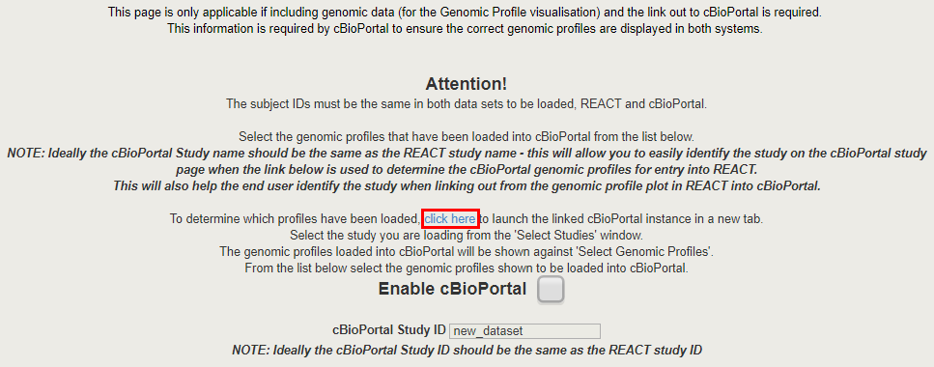

The linked cBioportal instance opens in a new browser tab.

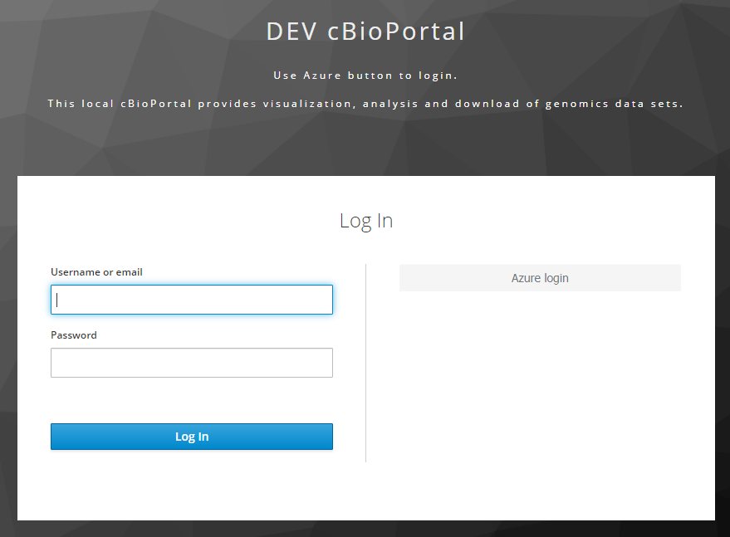

Enter appropriate credentials and log in.

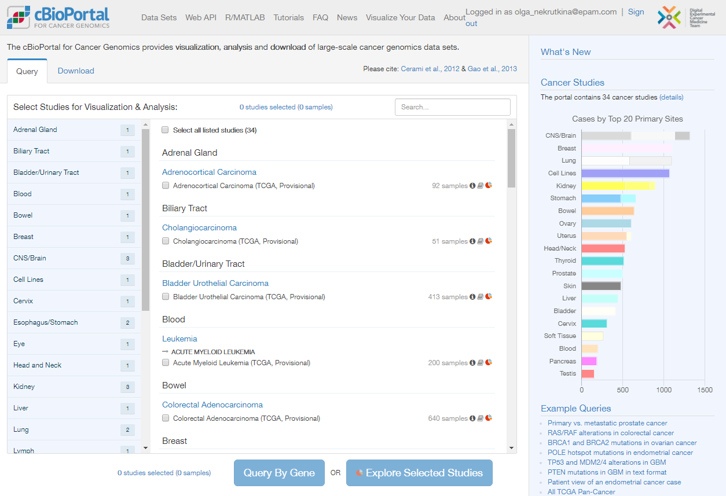

Select required study and click **Query by Gene**.

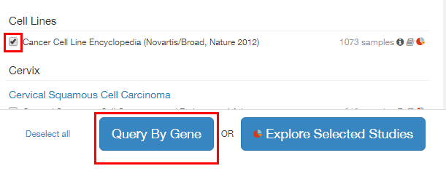

Available genomic profiles will be displayed. A user can select any of them in the AdminUI interface.

**Note**: Lists of available genomic profiles in REACT and cBioPortal may mismatch, so some genomic profiles for particular study in cBioPortal may have no analogs in the AdminUI interface.

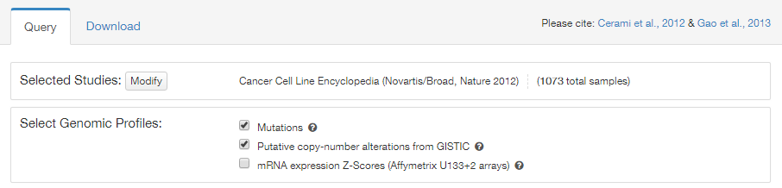

Return to the AdminUI and mark appropriate checkboxes.

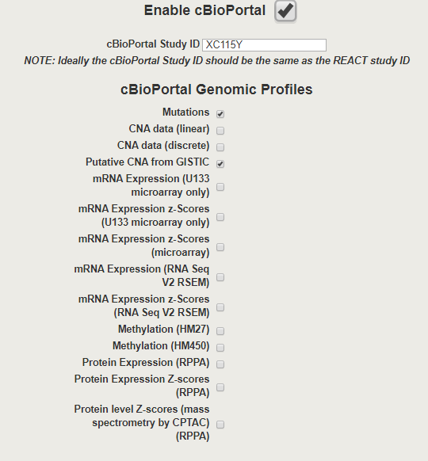

13. Click **Next** (or click on the successive item of the left menu).

### Review Dataset Setup

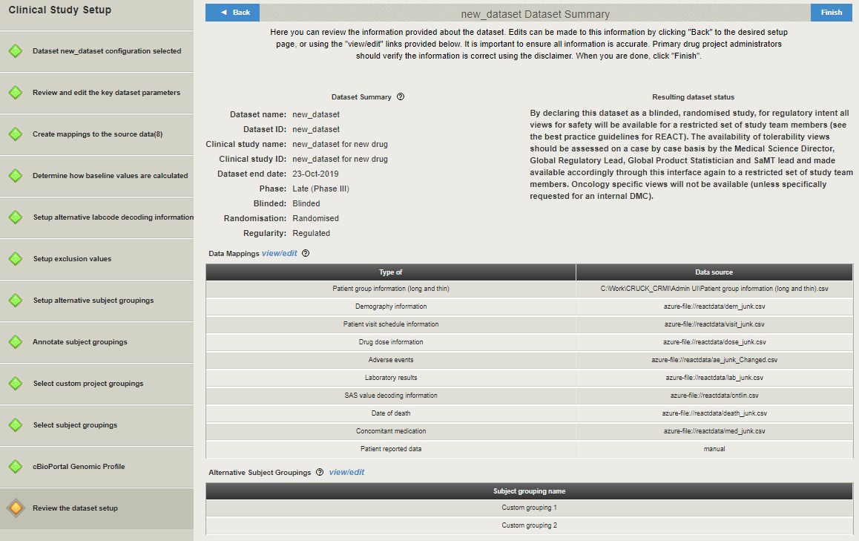

Here a user can view the summary of a new dataset.

Note that there is a disclaimer besides dataset summary blocks. By default, **I do not confirm…** radio-button is selected. UNLESS **I CONFIRM…** RADIO-BUTTON IS SELECTED, CURRENT DATASET WILL NOT BE USED IN REACT.

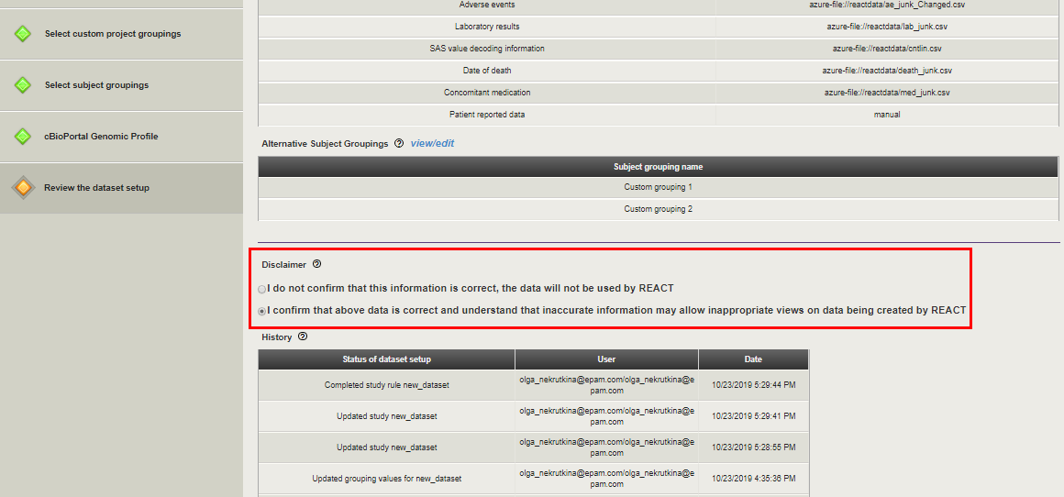

13. Go back to make changes or click **Finish**.

Click **Yes** in the pop-up confirmation window.

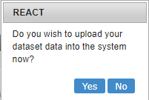

**Note**: If a user created a new dataset and did not click **Finish** (but clicked **REACT Admin** to return to home page), new dataset will appear in the datasets list, but a user will be unable to use it. In order to solve the issue, a user should select this dataset in the list, click **Edit**, and click **Finish** in the **Clinical Study Setup.** This action will run ETL job in order to load a dataset to the REACT. Job results are provided in the Data load report.

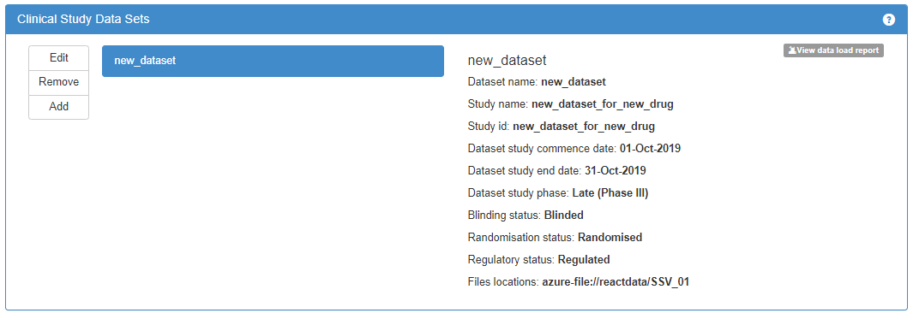

New dataset is added to the **Clinical Study Data Sets** section of the home page. Click on the dataset name in order to see the dataset summary to the right.

Click **View data load report** button to view the ETL job results. See Maintenance and Support section for details.

## Edit Dataset

1. Select required dataset and click **Edit**.

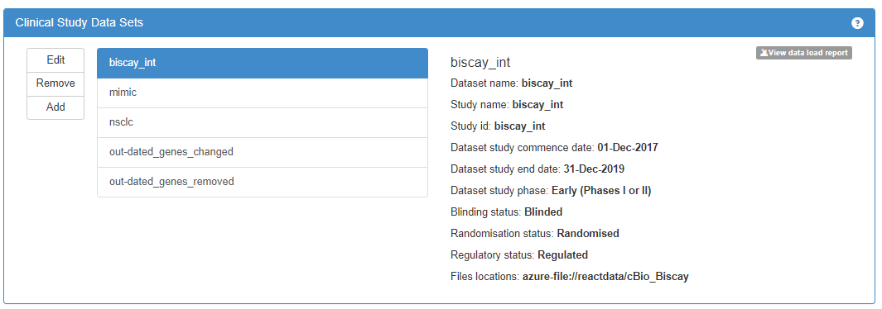

**Clinical Study Setup** opens, displaying dataset summary.

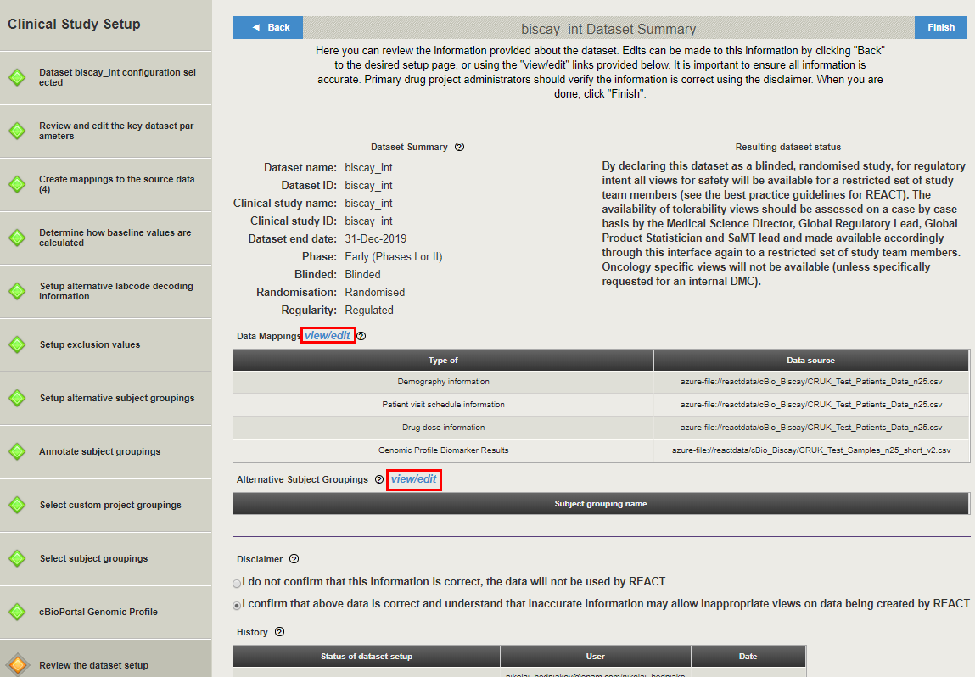

Use left menu items or **view/edit** links on the dataset summary page to open particular study setup pages in order to view or change dataset parameters. See Add Dataset section for details.

**Note**: Clicking padlock icon  is required to unlock the key dataset parameters and dataset exclusion values.

When all required changes are introduced, click **Finish** in order to save the dataset and run ETL job that will reload a dataset to the REACT.

# Highlevel Architecture Description

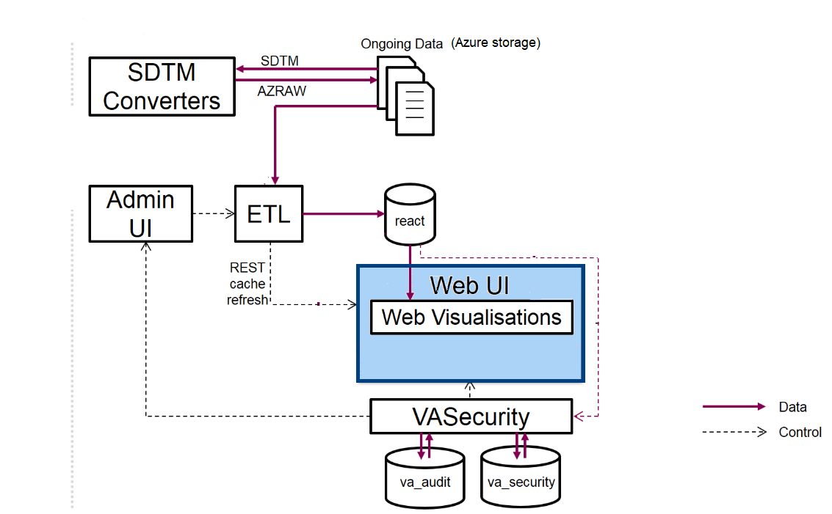

ACUITY system consists of the following components:

* **AdminUI/ETL** block performs automated data processing. It allows onboarding new clinical studies, editing mappings and conversion rules, running/scheduling ETL process for specific studies.
* **SDTM converters** perform conversion from SDTM to AZ RAW format.
* **VA-Security** provides authentication/authorization for application users.
* **VA-Hub web application** allows to create the clinical trials data visualizations.

The authorization process is illustrated on the diagram below.

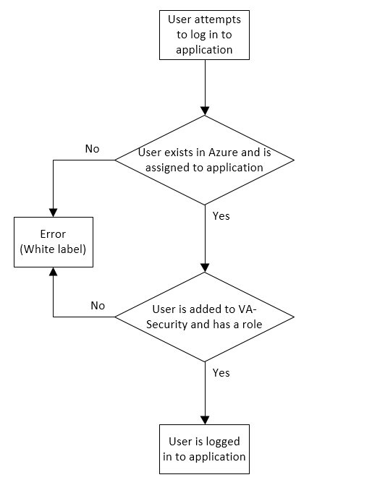

This diagram is suitable for any application – VA-Security, AdminUI or VA-Hub.

Besides, there are two ways to add a user to the system (both of them assume that a user is added to Azure Active Directory):

* Administrator opens VA-Security, adds a new user (see How to Add a New User section for details) and assigns some role to him/her.
* A user tries to log in to VA-Hub, and is automatically added to None Trained User group in VA-Security.

**Note**: In this case, a user still needs administrator to assign a role to him/her in order to be able to perform actions in any application (See Roles and Permissions section for details.)

# Maintenance and Support

## Data Load Report

After a user setup a dataset and clicked **Finish**, the ETL job runs to load a dataset into REACT. Additionally, if a dataset was scheduled, then ETL job runs every day. A user can view the data load report by clicking appropriate button.

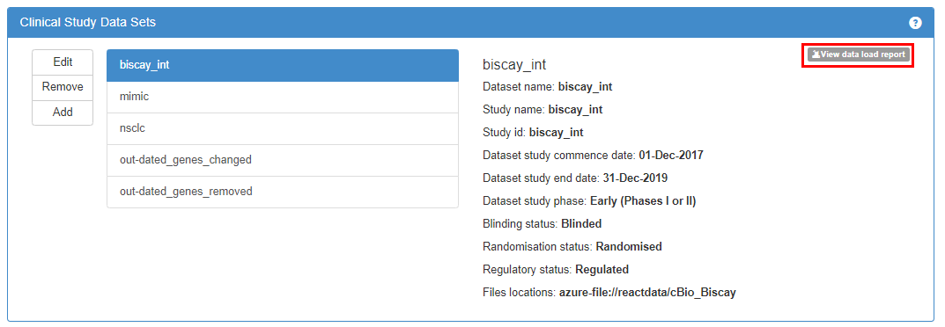

New browser tab opens.

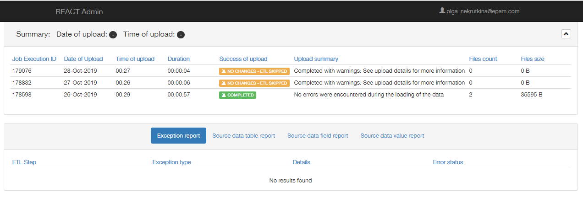

ETL data load report helps to support applications and identify root causes of problems (system issues, data problems, etc.)

Four levels of error/success reporting are available, listed below from most general to most specific. Each level corresponds to a table of data:

* A summary of an entire ETL process for a particular clinical study data set, followed by a summary of exception details, if such exception appears (**Data load summary** and **Exception** **report**);
* A set of upload statistics for every REACT data table for the given ETL run on the study data (**Source data table report**);

**Note**: Only includes 'mappable' data tables, which were mapped in the study setup UI, but not any 'system' related or secondary data tables;

* A set of upload statistics per REACT data field, based on whether the mapped data column in the raw data was successfully accessed and uploaded (**Source data field report**);

**Note**: Only includes fields that are mapped using the clinical study setup UI;

* A list of data values for which the upload was problematic (**Source data value report**).

Possible errors are classified by the following types:

1. "System error": An error condition that has caused by system fault, including an internal error, or a required component such as the REACT database being unavailable, or there is no study data mapping present in the REACT system (i.e., the database) for the study.
2. "Raw data source error": An error condition that is due to a problem with the source data not being available (e.g., network error, or data file server being unavailable which prevented the ETL from accessing the data files).
3. "Mapping error": An error condition associated with the data mapping parameters (e.g., a column name in the file does not exist)
4. "Data error": An error condition associated with the data within the file meaning that the data was not parsable for entry into the database (e.g., the data did not match the required type such as a string where an integer was expected).
5. "Upload Warning": Where the number of unique subjects in the source data is not equal to the number of subjects in the uploaded data.
6. "Data warning": Not strictly an error condition, where data in the raw file did not meet the desired format, so it was altered from how it appears in the source data.

### Data Load Summary

**Data load summary** section on the top of the page displays to a user information on 3 last uploads.

The following upload statuses are available here:

*  - ETL job completed without errors/warnings (no error types 1-5);
*  - ETL job completed with warnings (any error of type 4-5 was detected);
*  - scheduled ETL job was skipped because source data was unchanged;
*  - ETL job failed (any error of type 1-3 was detected).

If a user selects a particular upload in the list, upload details are displayed in the lower part of the page as a set of reports.

### Exception Report

**Exception report** provides a user with list of exception that arose during ETL job execution. If **Exception report** is not empty, then upload status is **Failed**.

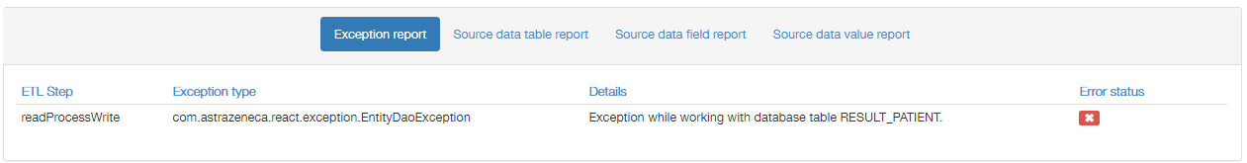

The most common exception types are described in Examples section.

### Source Data Table Report

**Source data table report** provides a user with a table where each mappable REACT data table (i.e., those tables that are mapped via the study setup UI) is shown as a row.

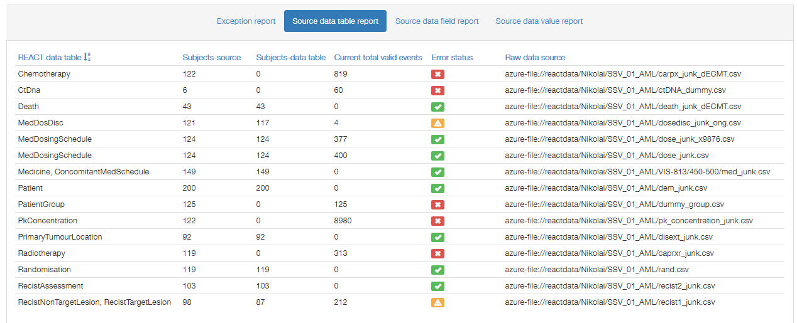

The following error statuses are available:

*  - no error of type 5;
*  - any error of type 5 except for the case described below;
*  - an error of type 5 where only one of either the number of unique subjects for the study in the source data table row is zero, or the number of unique subjects in the REACT data table row is zero.

### Source Data Field Report

**Source data field report** provides a user with a table where each row represents a single mapped data field in the REACT database.

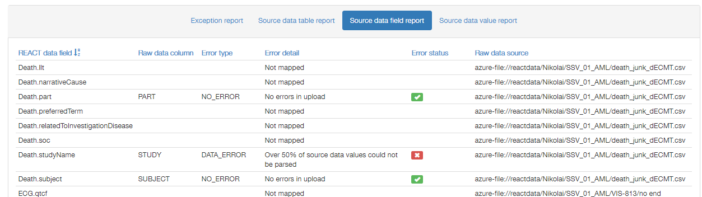

The following error statuses are available:

*  - no error of types 1-5;
*  - some but less than 50% of the values were not parsed due to type 4 errors;
*  - the data file is missing (type 2 error), the mapped column is missing (type 3 error) or more than 50% of the data values are of the wrong type;
* Not mapped - the REACT data field has not been mapped to the source data.

### Source Data Value Report

**Source data value report** provides a user with a table where each row represents a single mapped data value for which there has been a problem parsing or uploading that value into the specified REACT data field.

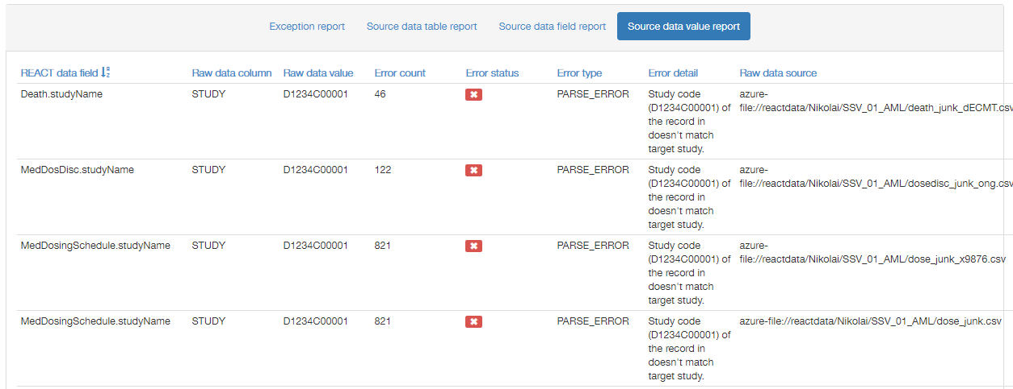

The following error statuses are available:

*  - an error of type 6 but not type 4, meaning that the value was parsed from the input data and uploaded to the system;
*  - more than 50% of the values were not parsed due to type 4 errors.

## Examples

This section provides examples of some errors that may appear when uploading the dataset into REACT. Some errors are related to the source data files, and potentially can be corrected by a user. Anyway, if a user has no idea of how to solve the issue, or an attempt to correct errors failed, the best way is to ask the support for help.

**Example 1**

Upload status: .

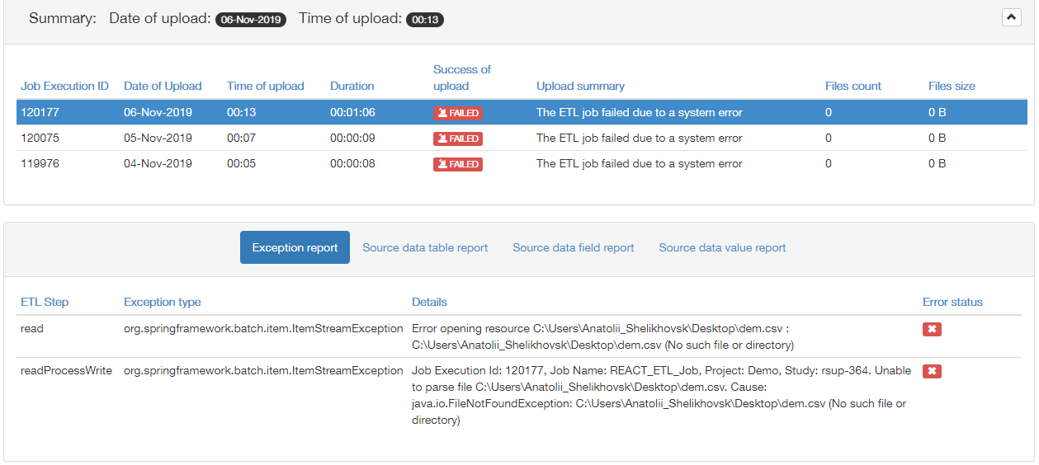

**Exception report** contains the following error: ‘Error opening resource (No such file or directory)’.

Solution: Such type of exception appears when the system cannot access the source file that was mapped in the study setup, and this file’s location is not the Azure storage. A user should check the path to the source file specified in the exception details.

**Example 2**

Upload status: .

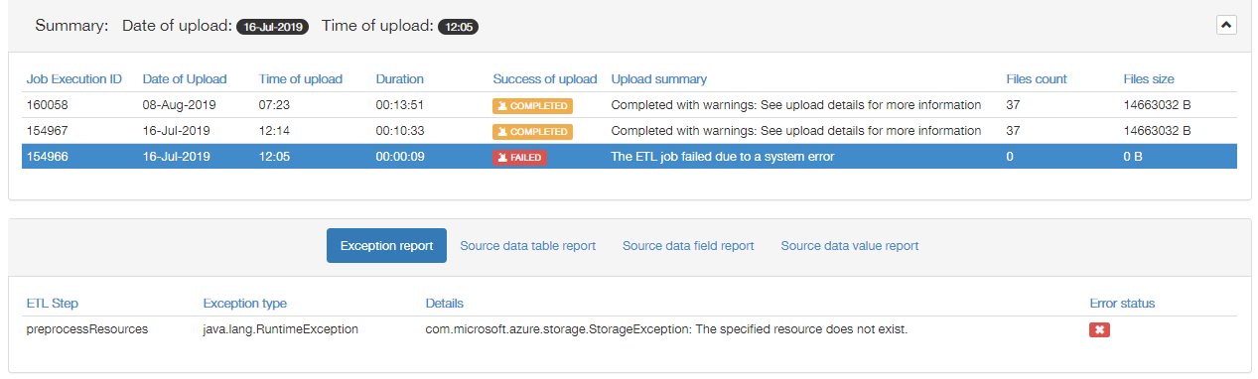

**Exception report** contains the following error: ‘com.microsoft.azure.storage.StorageException: The specified resource does not exist’.

Solution: Usually such type of exception appears when the system cannot access at the Azure storage at least one source file that was mapped in the study setup. A user should check all previously mapped source files at the Azure storage and verify their paths.

**Example 3**

Upload status: .

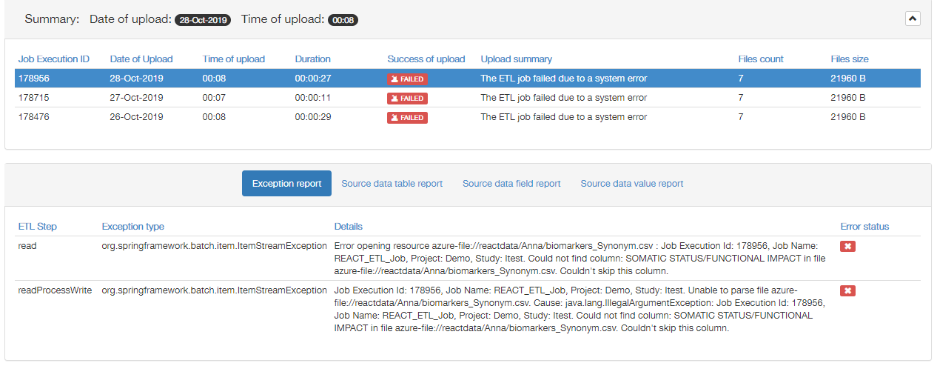

**Exception report** contains the following error: ‘Error opening resource. Couldn’t find column. Couldn’t skip this column’.

Solution: Usually such type of exception appears when the system can access the source file that was mapped in the study setup, but this file’s content does not fit the selected mapping (required columns are missed). A user should check the content of the source file specified in the exception details.

**Example 4**

Upload status: .

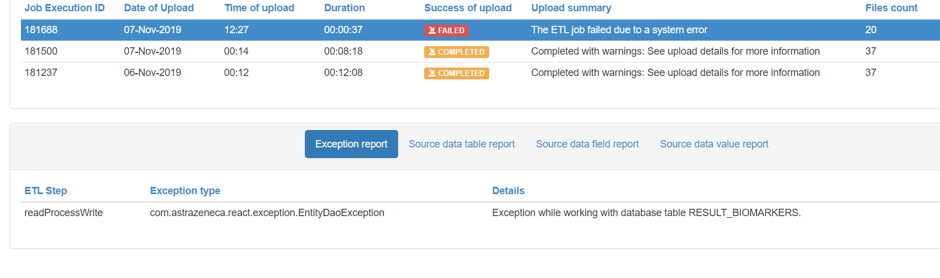

**Exception report** contains the following error: ‘Exception while working with database table’.

Solution: Usually such type of exception appears when some values in the mandatory columns of the source file are null. A user should perform the following actions:

1. Go to VA-Hub Database Tables and Mappings section of current document and find out which mapping corresponds to the database table specified in the exception details.
2. Go to the study setup and find out which columns of this mapping are mandatory, and which source file corresponds to the mapping (see the pictures below).

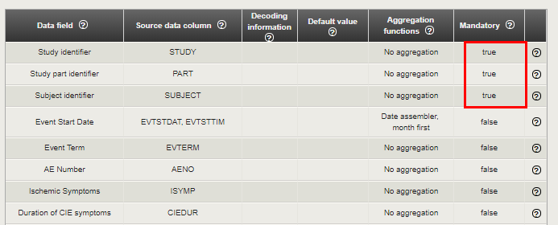

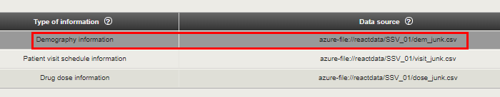

1. Open the source file and check the values in mandatory columns.

**Example 5**

Upload status: . There are no exceptions.

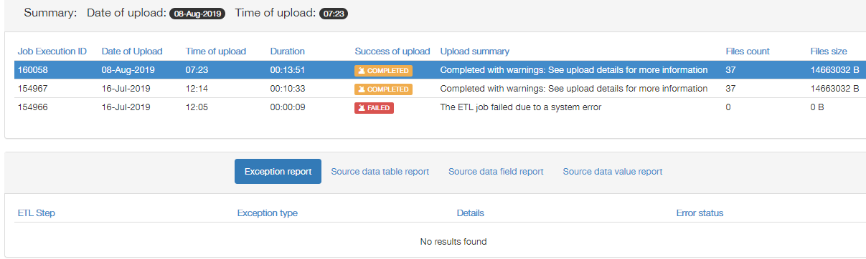

**Source data table report** contains some warnings. Let’s find the reason of the warning related to the AdverseEvent mapping.

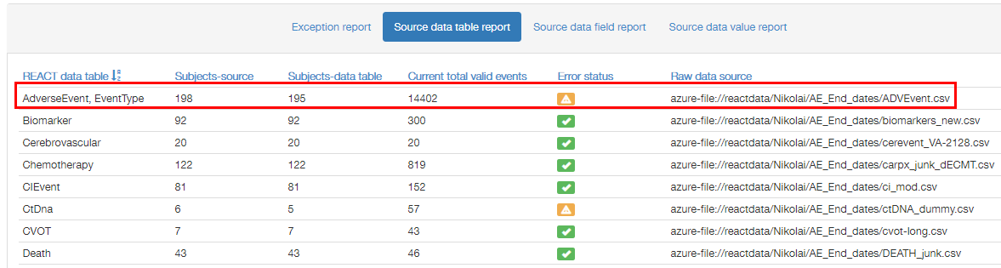

**Source data field report** provides us with the only warning related to AdverseEvent – in the AdverseEvent.number field.

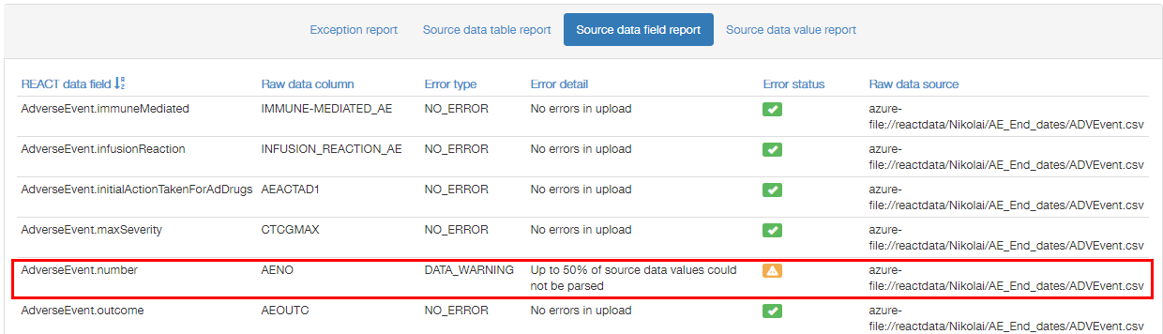

**Source data value report** provides us with the only error related to AdverseEvent.number field – ‘Unable to parse the following value: ‘.’

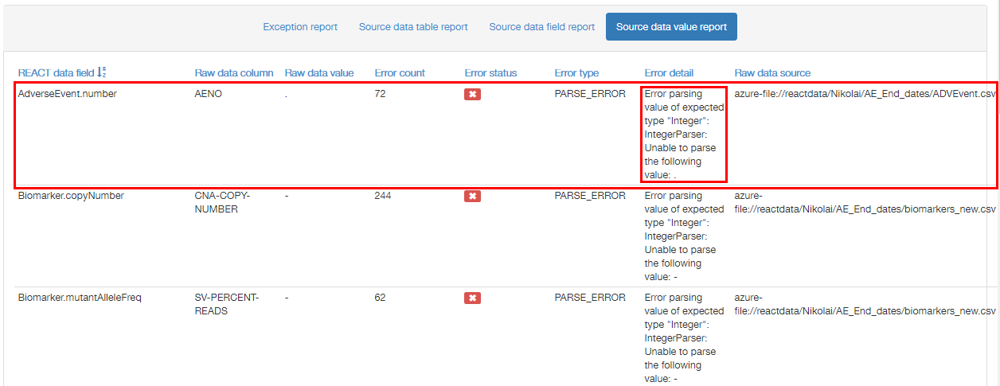

This information together with the name of source file (provided in all three reports) is enough to correct the error.

1. VA-Hub Database Tables and Mappings

| **View** | **Plots** | **Mappings** | **Tables** |
| --- | --- | --- | --- |
| **Population Summary** | Summary Plot | Demography information | RESULT_PATIENTS |
| **Dosing and Exposure** | Analyte Concentration | Specimen Collection PK Concentration | RESULT_SPECIMEN_COLLECTION RESULT_PK_CONCENTRATION |
| Dose Proportionality | Stacked PK Results | RESULT_STACKED_PK_RESULTS |
| PK-Response | Stacked PK Results Recist assessment summarised (recist2) Recist target lesion assessments (recist1) | RESULT_STACKED_PK_RESULTS RESULT_RECIST_ASSESSMENT RESULT_RECIST_TARGET_LESION |
| **Adverse Events** | AEs Subject Counts AEs Over Time AEs Table AE Summaries | Adverse events | RESULT_AE  RESULT_AE_CAUSALITY  RESULT_AE_SEVERITY |
| AEs Chord Diagram | Adverse events | RESULT_AE RESULT_AE_SEVERITY RESULT_EVENT_TYPE RESULT_AE_ACTION_TAKEN (not used for this plot at the moment) RESULT_AE_CAUSALITY (not used for this plot at the moment) |
| CI Event Counts CI Events Over Time Cerebrovascular Event Counts Cerebrovascular Event Over Time Additional CVOT Suspected Endpoint Counts Additional Suspected CVOT Endpoints Over Time | Adverse events Cerebrovascular event data Additional Suspected CVOT Endpoint data | RESULT_AE RESULT_CI_EVENT RESULT_CEREBROVASCULAR RESULT_CVOT |
| **Conmeds** | Conmeds Counts | Concomitant medication | RESULT_CONMED_SCHEDULE |
| **Labs** | Box Plot Shift Plot Line Plot | Laboratory results | RESULT_LABORATORY |
| **Vital Signs** | Vitals Measurements over Time | Vital signs | RESULT_VITALS |
| **Cardiac Functions** | Cardiac Measurements over Time | Cardiac data- ECG Cardiac data - LVEF | RESULT_ECG  RESULT_LVEF |
| **Liver Function** | Hy's Law | Laboratory results | RESULT_LABORATORY |
| **Reneal Function** | Creatinine Clearance CKD Distribution | Laboratory results | RESULT_LABORATORY |
| **Respiratory** | Exacerbations Counts Lung Function Measurements Over Time Exacerbations Over Time Exacerbations Onset | Exacerbations Lung function Exacerbation classification rules | RESULT_EXACERBATION RESULT_LUNGFUNC |
| **Tumor Response** | Waterfall plot | Recist assessment summarised (recist2) Recist target lesion assessments (recist1) | RESULT_RECIST_ASSESSMENT RESULT_RECIST_TARGET_LESION |
| TL diameters over time | Recist assessment summarised (recist2) Recist target lesion assessments (recist1) | RESULT_RECIST_ASSESSMENT RESULT_RECIST_TARGET_LESION |
| Prior therapy vs. Time on compound | Chemotherapy information (caprx) Radiotherapy information (caprxr) Disease Extent Pathology Patient group information (long and thin) + Alternative Subject Groupings | RESULT_CHEMOTHERAPY RESULT_RADIOTHERAPY RESULT_DISEASE_EXTENT RESULT_PATHOLOGY MAP_SUBJECT_GROUP* (PRECALC_DEMO also contains subject groupings information) |
| **Oncogenic Biomarkers** | Genomic Profile | Genomic Profile Biomarker Results | RESULT_BIOMARKERS |
| ctDNA | Circulating tumor DNA | RESULT_CTDNA |
| **Timeline** | Timeline | Patient reported data | RESULT_PATIENT_REPORTED_DATA |
| **Single Subject** | ~ | ~ | ~ |
| **Cohort Editor** | ~ | ~ | ~ |
| **Machine Insights** | QT intervals | ECG - Legacy AZ Raw format Concomitant medication Adverse events Laboratory results | RESULT_ALGORITHM_OUTCOMES |
| **My Dashboard** | ~ | ~ | ~ |

1. Roles and Permissions

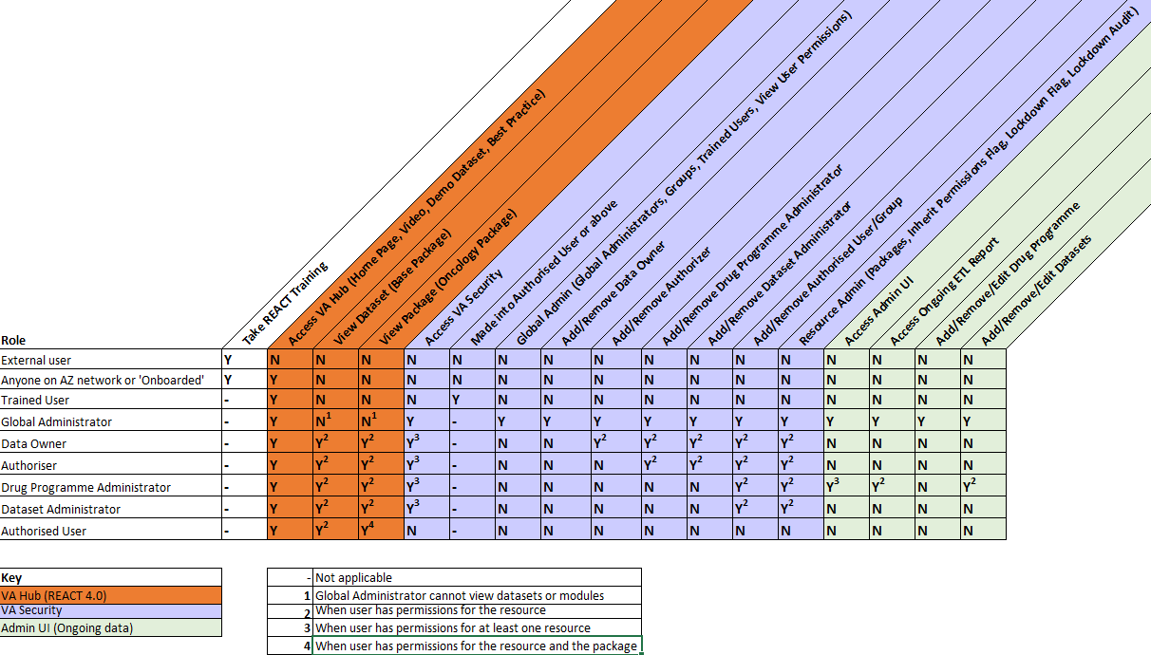

1. Aggregation Functions

Aggregation functions allow the system to implement some complicated data mapping requirements. For most data being mapped, no aggregation is required.

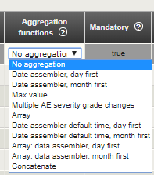

The available aggregation functions are described below.

**Date assembler, day first**

**Date assembler, month first**

These functions allow to provide the system with the information whether the day or month goes first in the date representation in source file.

Usage example:

**Date of death** mapping

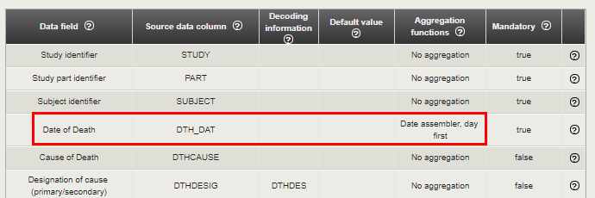

**Note:** The same aggregation function is used when taking data from two source data columns (date and time).

**Additional Suspected CVOT Endpoint data** mapping

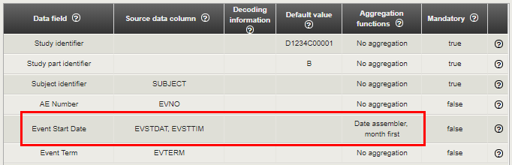

**Max value**

This aggregation function allows to choose the maximum value from a number of source data column values.

Usage example:

**Adverse events** mapping

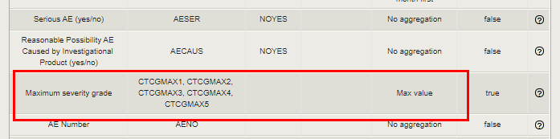

|  |  |  |  |  |
| --- | --- | --- | --- | --- |
| **Source data column 1 value** | **Source data column 2 value** | **Source data column 3 value** | **Source data column 4 value** | **Data field value** |
| 12 | 5 | 10 | 1 | 12 |

**Array**

This aggregation function is only used for **Adverse events** mapping. It allows to take values from a number of source data columns and write them into one column of the database.

**Note**: The data is ordered automatically.

Usage example:

**Adverse events** mapping

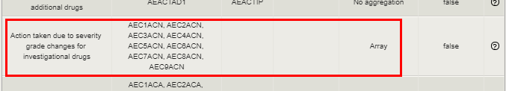

| **Source data column 1 value** | **Source data column 2 value** | **Source data column 3 value** | **Source data column 4 value** | **Data field value** |
| --- | --- | --- | --- | --- |
| Dose Not Changed | Dose Increased | Dose Reduced | Drug Interrupted | Dose Not Changed  Dose Increased  Dose Reduced  Drug Interrupted |

**Multiple AE severity grade changes**

This aggregation function is only used for **AE severity grade changes** and **AE severity change dates** fields. Both fields require using **Array** aggregation function, but their values should be paired (each severity grade change has its own date). Multiple AE severity grade changes aggregation function provides such pairing.

Usage example:

**Adverse events** mapping

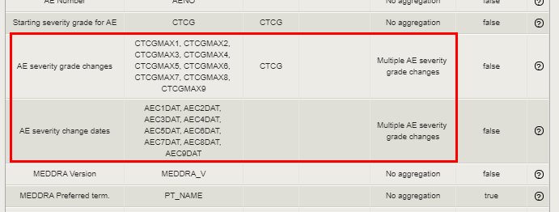

**Date assembler default time, day first**

**Date assembler default time, month first**

These functions allow to provide the system with the information whether the day or month goes first in the date representation in source file. Date is followed by the time value, taken from the Default value column of the mapping table.

Usage example:

**Exacerbations** mapping

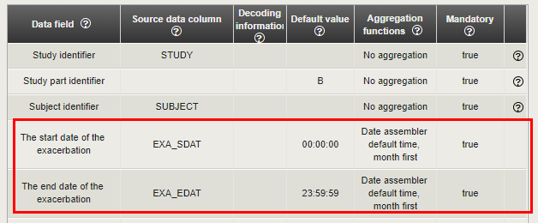

|  |  |
| --- | --- |
| **Source data column value** | **Data field value** |
| 01/16/2018 | 01/16/2018 23:59:59 |

**Array: Date assembler, day first**

**Array: Date assembler, month first**

These functions allow to take date values from a number of source data columns and write them into one column in the database, also providing the system with the information whether the day or month goes first in the date representation in source file.

Usage example:

| **Source data column 1 value** | **Source data column 2 value** | **Source data column 3 value** | **Source data column 4 value** | **Data field value** |
| --- | --- | --- | --- | --- |
| 16/01/2018 | 22/01/2018 | 28/03/2018 | 29/04/2018 | 16/01/2018  22/01/2018  28/03/2018  29/04/2018 |

**Concatenate**

This aggregation function can be used for fields that contain long description. The long description is usually split into several variables during the data extraction process, and **Concatenate** function allows to gather the description into one database cell.

**Note**: Strings from mapped into the field columns are concatenated without any separators.

Usage example:

**Hospitalizations** mapping

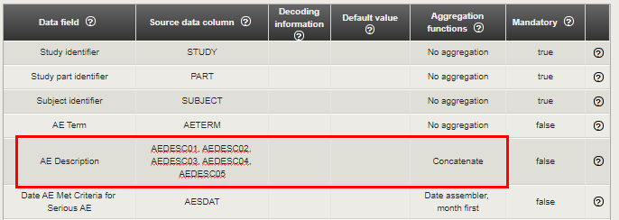

| **Source data column 1 value** | **Source data column 2 value** | **Source data column 3 value** | **Source data column 4 value** | **Data field value** |
| --- | --- | --- | --- | --- |
| The findings show that 13% of all home healthcare patients had an adverse event, with 80% experiencing only 1 adverse event. | More than three fourths of the adverse events were associated with discharge to the | community and required continued assistance. Patients who experienced adverse events were older, had more | depressive symptoms and behavioral problems, and were more functionally impaired. | The findings show that 13% of all home healthcare patients had an adverse event, with 80% experiencing only 1 adverse event. More than three fourths of the adverse events were associated with discharge to the community and required continued assistance. Patients who experienced adverse events were older, had more depressive symptoms and behavioral problems, and were more functionally impaired. |

1. Mappings Details

The following data types are used in the system:

* Mandatory patient information group:
* Demography information
* Patient visit schedule information
* Drug dose information
* Oncology specific information group:
* Disease lesion information
* Recist assessment summarized
* Radiotherapy information
* Chemotherapy information
* Recist target lesion assessments
* Recist non-target lesion assessments
* Foundation Medicine Gene Variant Summary
* Pathology
* Disease Extent
* Concomitant procedures
* Respiratory specific information group:
* Exacerbations
* Lung function
* Exacerbation classification rules
* e-Diary
* CV Specific Information group:
* CI Events
* Optional patient information group:
* Randomization dates
* Countries
* Concomitant medication
* Dose discontinuation information
* Date of death
* Patient group information (long and thin)
* Withdrawal/Completion
* Subject Characteristics
* Patient group information (short and wide)
* Informed Consent
* Substance Use - Nicotine
* Pregnancy Test
* Substance Use - Alcohol
* Patient reported data
* PK and Biomarkers group:
* Specimen Collection
* PK Concentration
* Stacked PK Results
* Genomic Profile Biomarker Results
* Circulating tumor DNA
* Patient safety information group:
* Adverse events
* Hospitalizations
* Laboratory results
* ECG - Legacy AZ Raw format
* ECG
* Cardiac data - DECG
* Cardiac data - LVEF
* Vital signs - Legacy AZ Raw format
* Vital signs
* Medical History
* Surgical history
* Liver diagnostic investigation
* Performance Status
* Liver signs and symptoms
* Overdose Report
* Liver risk factor
* Value decoding group:
* SAS value decoding information
* CVOT Specific Information group:
* Additional Suspected CVOT Endpoint data
* Cerebrovascular event data

Detailed description of mapping fields for some data types is provided below.

**Demography information**

|  |  |  |  |
| --- | --- | --- | --- |
| **Data field** | **Description** | **Mandatory** | **Type** |
| Study identifier | The study identifier | Y | Text |
| Study part identifier | The study part identifier | Y | Text |
| Subject identifier | The subject identifier | Y | Text |
| Centre number | The identifier for the study centre | N | Number |
| Sex | The sex of the subject | N | Text |
| Race | The race of the subject | N | Text |
| Visit date | The date of the subject visit | N | Date |
| Date of birth | Birth date of subject | N | Date |

**Patient visit schedule information**

|  |  |  |  |
| --- | --- | --- | --- |
| **Data field** | **Description** | **Mandatory** | **Type** |
| Study identifier | The study identifier | Y | Text |
| Study part identifier | The study part identifier | Y | Text |
| Subject identifier | The subject identifier | Y | Text |
| Visit number | The number of the subject visit | Y | Number |
| Visit date | The date of the subject visit | Y | Date |

**Drug dose information**

|  |  |  |  |
| --- | --- | --- | --- |
| Data field | Description | Mandatory | Type |
| Study identifier | The study identifier | Y | Text |
| Study part identifier | The study part identifier | Y | Text |
| Subject identifier | The subject identifier | Y | Text |
| Study Drug Name | The name of study drug (investigational product) | Y | Text |
| Study Drug Total Daily Dose | The total daily dose of study drug | N | Number |
| Dose per Administration | The dose of medication given to subject per administration | Y | Number |
| Dose Unit | The unit in which the dose amount is measured | N | Text |
| Start date/time of the dose schedule | The date of first dose scheduled | Y | Date/Time |
| Medication Code | The Medication Code of study drug | N | Text |
| End date/time of the dose schedule | The date of last dose scheduled | N | Date/Time |
| Treatment Cycle Delayed (yes/no) | Whether treatment cycle was delayed or not (Y/N) | N | Text |
| Dosing Frequency | The dosing frequency, e.g. ‘BID’ for twice-daily. This field will be used in precedence over the dosing frequency per interval and interval unit fields | N | Text |
| Reason Treatment Cycle Delayed | The reason why treatment cycle was delayed | N | Text |
| Dosing Frequency (per Interval) | The dosing frequency per interval | N | Number |
| Medication Dictionary text | A value that provides the Medication Code of study drug | N | Text |
| Dosing Frequency Interval Unit | The unit of dosing frequency | N | Text |
| Reason Treatment Cycle Delayed, Other | The alternative reason why treatment cycle was delayed | N | Text |
| Study Drug ATC Code | The ATC code of study drug | N | Text |
| ATC Dictionary Text | The ATC dictionary text of study drug | N | Text |
| Action Taken, Study Drug | Type of change being made to the dosing schedule | N | Text |
| Study Drug Preferred Name | The preferred name of study drug | N | Text |
| Main Reason for Action Taken, Study Drug | The main reason for change being made to the dosing schedule | N | Text |
| Reason for Study Drug Dose Change Specification | The further reason for change being made to the dosing schedule | N | Text |
| Medication Grouping Name | Preferred grouping term of study drug | N | Text |
| Active Ingredient | The active ingredient of study drug (more than one can be provided, so aggregation function should be possible) | N | Text |
| Study Drug Category | The study drug category | N | Text |
| Planned Dose | The planned dose of study drug | N | Number |
| Planned Dose Units | The planned dose units of study drug | N | Text |
| Planned No. of Days Treatment | The planned number of treatment days | N | Number |
| AE number caused Action taken | The AE number caused action taken for study drug (aggregation should be possible) | N | Number |
| Formulation | The formulation of study drug | N | Text |
| Study Drug Route | The route of study drug | N | Text |
| Reason for Therapy | The reason for therapy | N | Text |
| AE number caused Treatment Cycle Delayed | The AE number caused treatment cycle delayed (aggregation should be possible) | N | Number |

**Adverse Events mapping**

| **Data field** | **Description** | **Mandatory** | **Type** |
| --- | --- | --- | --- |
| Study identifier | The study identifier | Y | Text |
| Study part identifier | The study part identifier | Y | Text |
| Subject identifier | The subject identifier | Y | Text |
| AE Term | The term used to describe type of the adverse event | N | Text |
| AE Start Date | The start date of the event | Y | Date/Time |
| AE End Date | The end date of the event | N | Date/Time |
| Serious AE (yes/no) | Whether the AE was flagged as serious (Yes/No) | N | Text |
| Reasonable Possibility AE Caused by Investigational Product (yes/no) | Whether the AE was probably caused by Investigational Product | N | Text |
| Maximum severity grade | The max severity the AE achieved for the period specified (either AE CTC grade or AE Intensity grade can be used) | Y | Text |
| AE Number | The number assigned to the associated AE record | N | Number |
| Starting severity grade for AE | Starting severity grade for AE (either AE CTC grade or AE Intensity grade can be used) | N | Text |
| AE severity grade changes | Changes of AE severity grade over time (either AE CTC grade or AE Intensity grade can be used). If multiple severity grade columns are provided, these should be entered in the order that they occurred, separated by commas, corresponding to the dates provided in ‘AE severity change dates’ column. Note that aggregation function must be selected | N | Text |
| AE severity change dates | Dates of AE severity grade changes. If multiple date columns are provided, these should be entered in the order that they occurred, separated by commas, corresponding to the severity values provided in ‘AE severity grade changes’ column. Note that aggregation function must be selected | N | Date/Time |
| MEDDRA Version | The MEDDRA Version used to code the AE | N | Text |
| MEDDRA Preferred term | The MedDRA preferred term assigned to the AE | Y | Text |
| MEDDRA Higher-Level Term | The MedDRA Higher-Level Term for the AE | N | Text |
| MEDDRA Low-Level Term | The MedDRA Low-Level Term for the AE | N | Text |
| MEDDRA System Organ Class | The MedDRA System Organ Class of experienced AE | N | Text |
| Action taken | What action was taken due to the AE | N | Text |
| Investigational drug names | Names of the investigational drug | N | Text |
| Additional drug names | Names of the additional drug | N | Text |
| Initial action taken for investigational drugs | What action was taken due to the AE (investigational drugs) | N | Text |
| Initial action taken for additional drugs | What action was taken due to the AE (additional drugs) | N | Text |
| Action taken due to severity grade changes for investigational drugs | What action was taken due to severity grade changes (investigational drugs) | N | Text |
| Action taken due to severity grade changes for additional drugs | What action was taken due to severity grade changes (additional drugs) | N | Text |
| Causality for investigational drugs | Whether it is thought the AE is caused by the investigational drug (Yes/No) | N | Text |
| Causality for additional drugs | Whether it is thought the AE is caused by the additional drugs (Yes/No) | N | Text |
| AE Outcome | **Current state of the AE (e.g., resolved, recovering etc.)** | N | Text |
| Dose Limiting Toxicity | Whether the AE represents a level of toxicity that causes dose to be limited, reduced or stopped. (Yes/No) | N | Text |
| Time Point For Dose Limiting Toxicity | Description of the time point at which the AE reached a dose limiting toxicity (e.g. cycle number, visit number, date etc.) | N | Date/Time |
| Immune-mediated AE | Whether the AE is driven by immune system imbalance (Yes/No) | N | Text |
| Infusion Reaction AE | Whether the AE relates to the administration of drug via IV infusion (Yes/No) | N | Text |
| AE Required Treatment | Whether AE required treatment (Yes/No) | N | Text |
| AE Caused Subject Withdrawal | Whether AE caused subject withdrawal (Yes/No) | N | Text |
| Suspected Endpoint | Suspected clinical endpoint | N | Text |
| Suspected Endpoint Category | A category of suspected clinical endpoint | N | Text |
| AE of Special Interest | A custom grouping of AE terms that may have been mapped specifically for the given study or set of studies | N | Text |
| Comment | Comment | N | Text |

**Note**: Number of elements in **Investigational drug names** should be equal to number of elements in **Initial action taken for investigational drugs**.

**Note**: Number of elements in **Additional drugs** should be equal to number of elements in **Initial action taken for additional drug.**

**Laboratory results mapping**

| **Data field** | Description | **Mandatory** | **Type** |
| --- | --- | --- | --- |
| Study identifier | The identifier for the study | Y | Text |
| Study part identifier | The identifier for the study part | Y | Text |
| Subject identifier | **The identifier for the subject** | Y | Text |
| Visit number | The number of the subject visit | N | Number |
| Date of the measurement | |  |  | | --- | --- | |  | Date of taken measurement | | Y | Date/Time |
| Laboratory Test Identifier | **The laboratory code** | Y | Text |
| Laboratory Value | **The result value** | N | Number |
| Laboratory Test Unit | **The units used for measuring laboratory value** | N | Text |
| Lower reference Value | A lower reference limit for the laboratory test result | N | Text |
| Upper Reference Value | An upper reference limit for the laboratory test result | N | Text |
| Comment | A comment that accompanies the result | N | Text |
| Laboratory Value Dipstick | A value that describes laboratory value dipstick | N | Text |
| Protocol schedule time point | A value that describes the protocol schedule time point of the measurement | N | Text |
| Source type | A value that describes where the data come from (Sponsor/Patient) | Y | Text |
| Device source name | A value that describes name of the device through which the data were taken | N | Text |
| Device source version | A value that describes version of the device through which the data were taken | N | Text |
| Device source type | A value that describes type of device through which the data were taken | N | Text |

**Validation rules for fields in REACT**

**(**otherwise records are removed**)**

* Adverse Event and Dose should have Start Date;
* Adverse Event and Dose Start Date should be before End Date.

**Rules for particular tables**

*RESULT_TRG_MED_DOS_SCHEDULE table*

* Dose is not NULL;
* Start date is not NULL;
* Start date is not in the future;
* Start date before the end date;
* Start date before the death date;
* Start date before the withdrawal date.

*RESULT_DEATH table*

* Death date is not NULL;
* Death date is not in the future.

*RESULT_TARGET_MED_DOS_DISC table*

* Discontinuation date is not NULL;
* Discontinuation date is not in the future;
* Discontinuation date before the death date;
* Discontinuation date before the withdrawal date.

*RESULT_WITHDRAWAL_COMPLETION table*

* Withdrawal date is not NULL;
* Withdrawal date is not in the future.

*RESULT_RECIST_TARGET_LESION table*

* Lesion date is not NULL;
* Lesion date is not in the future.

*RESULT_RECIST_NONTARGET_LESION table*

* Lesion date is not NULL;
* Lesion date is not in the future.

*RESULT_AE_SEVERITY table*

* Start date is not in the future;
* Start date before the end date.

1. SAS Value Decoding

**SAS value decoding information** mapping:

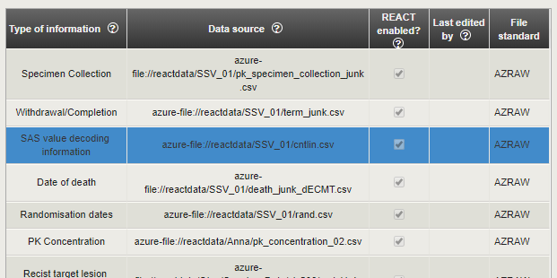

Clicking on the data source link opens another browser tab with appropriate source .csv file (a table with ~500 rows).

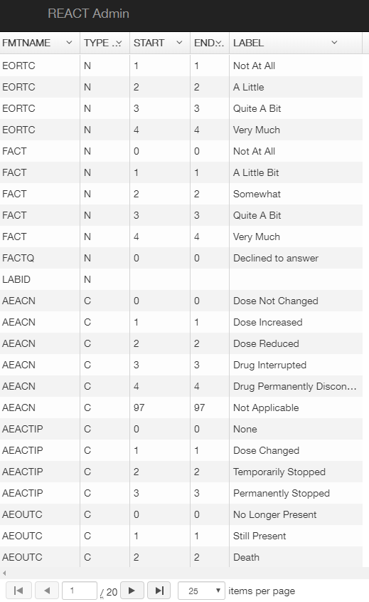

**SAS value decoding information** mapping provides a user with the following information: START coded values are taken from source data files and decoded to meaningful LABEL values for particular code group name FMTNAME.

**Note**: END values can be used to provide START-END range of values to be decoded into meaningful LABEL values.

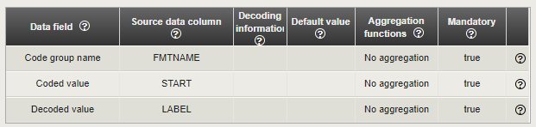

Let’s look at some examples.

**Example 1**

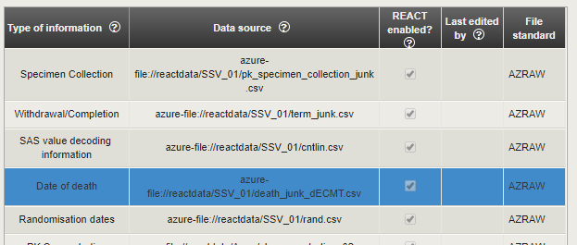

**Date of death** mapping uses decoding option.

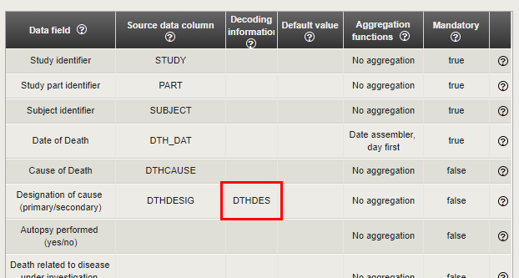

**Designation of cause** data field value

The value from DTHDESIG source data column is taken and decoded using DTHDES code group name of decoding source file.

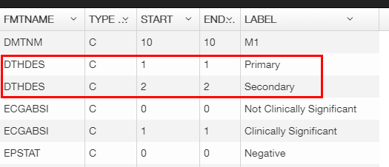

START and LABEL columns should be used, providing the following dependence:

* If the value from DTHDESIG source data column is equal to 1, then resulting value for the **Designation of cause** data field is ‘Primary’;
* If the value from DTHDESIG source data column is equal to 2, then resulting value for the **Designation of cause** data field is ‘Secondary’.

**Example 2**

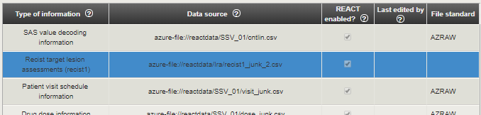

**Recist target lesion assessments (recist1)** mapping uses decoding option.

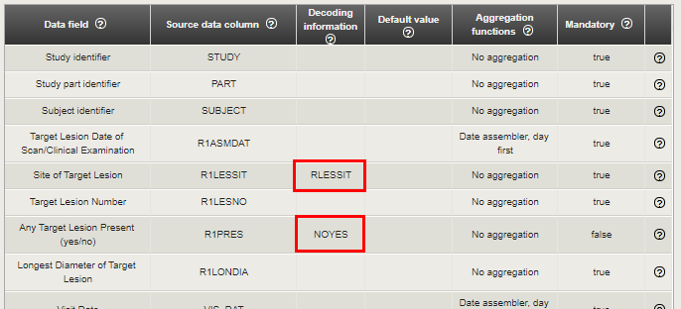

**Site of Target Lesion** data field value

The value from R1LESSIT source data column is taken and decoded using RLESSIT code group name of decoding source file.

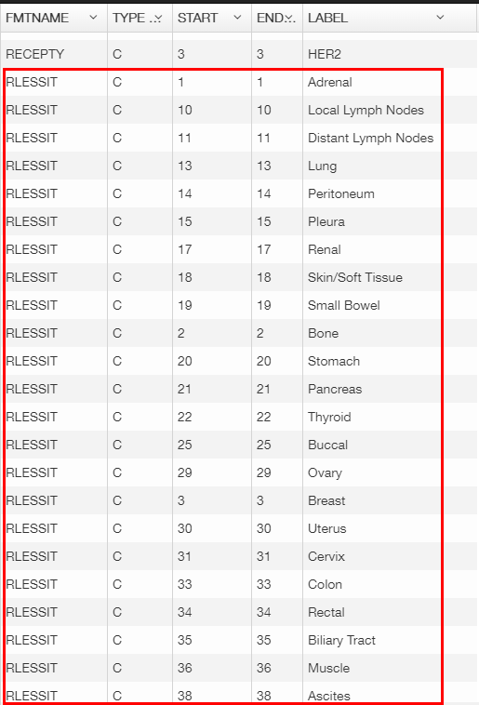 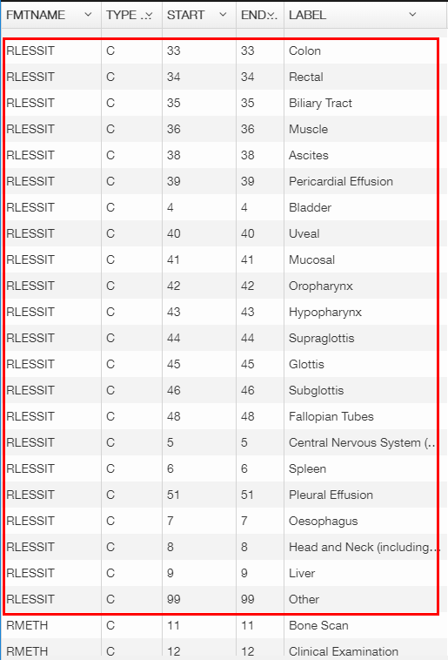

START and LABEL columns should be used, providing the following dependence:

* If the value from R1LESSIT source data column is equal to 1, then resulting value for the **Site of Target Lesion** data field is ‘Adrenal;
* If the value from R1LESSIT source data column is equal to 9, then resulting value for the **Site of Target Lesion** data field is ‘Liver;
* Etc.

**Any Target Lesion Present** data field value

The value from R1PRES source data column is taken and decoded using NOYES code group name of decoding source file.

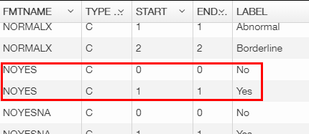

START and LABEL columns should be used, providing the following dependence:

* If the value from R1PRES source data column is equal to 0, then resulting value for the **Any Target Lesion Present** data field is ‘No’;
* If the value from R1PRES source data column is equal to 1, then resulting value for the **Any Target Lesion Present** data field is ‘Yes’.

**Example 3**

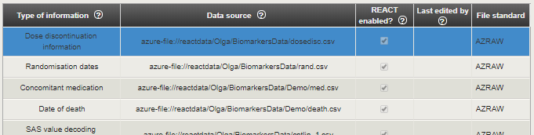

**Dose discontinuation information** mapping uses decoding option.

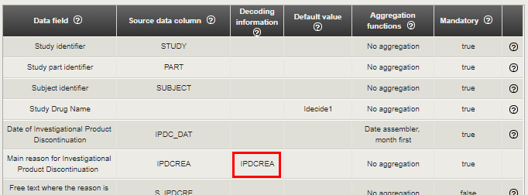

**Main reason for Investigational Product Discontinuation** data field value

The value from IPDCREA source data column is taken and decoded using IPDCREA code group name of decoding source file.

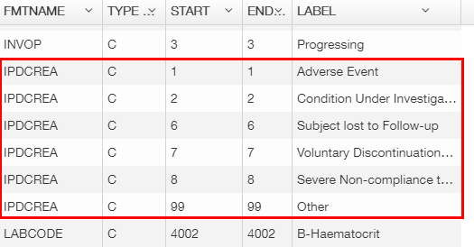

START and LABEL columns should be used, providing the following dependence:

* If the value from IPDCREA source data column is equal to 1, then resulting value for the **Main reason for Investigational Product Discontinuation** data field is ‘Adverse Event’;
* If the value from IPDCREA source data column is equal to 6, then resulting value for the **Main reason for Investigational Product Discontinuation** data field is ‘Subject lost to Follow-up’;
* Etc.

1. How to Add a New User
2. Add a user into the Azure Active Directory.
3. Log into VA-Security.
4. Click on the right top icon and choose **Edit Trained users**.

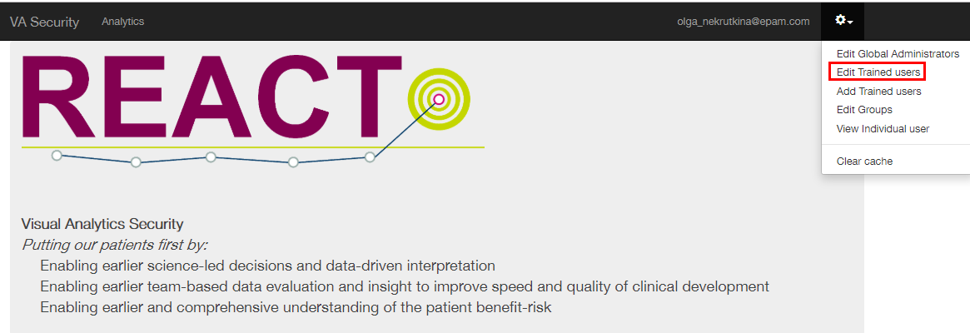

1. Write user's email in the field **Search for New User**.

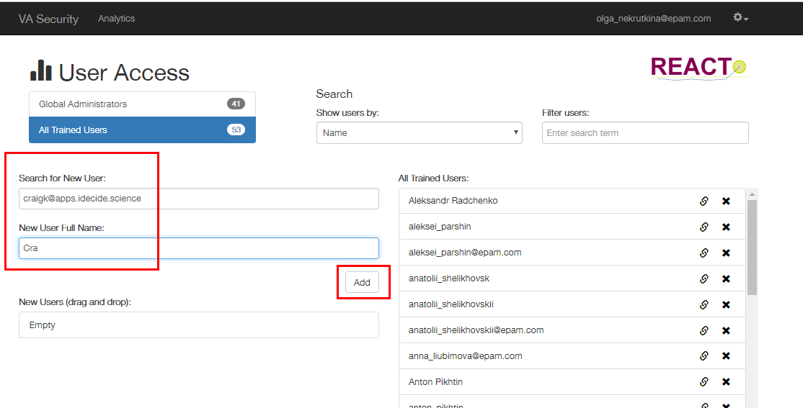

1. Write user's First Name and Second Name in the field **New User Full Name**.
2. Click **Add**.